Growing Witnessing Communities
  - Student Handouts

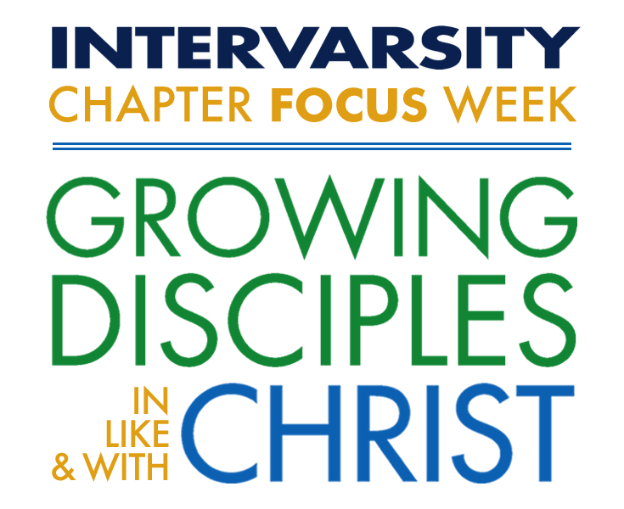

Table of Contents

Track Overview 4
Purpose Statement 4
Track Description for students 4
Retreat of Silence Guide (ROS) 5
Invite 5
Reflect 5
Consider 6
Read 6
Discover 6
Respond 7
Pray 7
Quiet Time Guide 8
Monday Quiet Time Guide 8
1. Reflect 8
2. Read 8
3. Discover 8
4. Respond 8
5. Pray 8
6. Acts 9:1-22 9
Tuesday Quiet Time Guide 10
1. Reflect 10
2. Read 10
3. Discover 10
4. Respond 10
5. Pray 10
6. Acts 9:1-22 11
Wednesday Quiet Time Guide 12
1. Reflect 12
2. Read 12
3. Discover 12
4. Respond 12
5. Pray 12
6. Acts 3 13
Thursday Quiet Time Guide 14
1. Reflect 14
2. Read 14
3. Discover 14
4. Respond 14
5. Pray 14
6. Luke 16:1-13 [NRSV] 15
Track Sessions 16
Sunday 4 PM 16
1. Session Goal 16
2. Three Stages of Communities 16
3. 5 Thresholds Overview Worksheet 19
4. 30 Second Vision Talk 20
5. Reflection questions 20
Sunday 7:45 PM 21
1. 100 Ideas for Fun Handout 21
Monday 9 AM 23
1. Session Goals Error! Bookmark not defined.
2. Growing in Telling Your Story 23
c. During: 23
d. After: 23
e. BRIDGE 23
3. Luke 15:11-32 24
4. Reflection questions Error! Bookmark not defined.
Monday 4 PM 26
1. Session Goals Error! Bookmark not defined.
2. Luke 14:12-24 26
3. Prayer Mapping Worksheet 27
4. First Threshold Discipleship Cycle 28
Tuesday 9 AM 29
1. Session Goals Error! Bookmark not defined.
2. Risk Taker Quiz Error! Bookmark not defined.
3. Acts 16:11-15 30
4. Reflection questions Error! Bookmark not defined.
Wednesday 9 AM 31
1. Threshold 4: Being Seekers, Helping Seekers 31
2. This week will . . . 32
3. 5 Thresholds VPS Planning Sheet Error! Bookmark not defined.
Wednesday 4 PM 34
1. Session Goals Error! Bookmark not defined.
2. The Big Story Booklet 34
3. Gospel Pieces Handout 34
1. Gospel pieces 34
Thursday 9 AM 35
1. Session Goals Error! Bookmark not defined.
2. Luke 16:1-15 35
3. Lewin’s Force Field Worksheet 37
4. Grow Coaching Sheet for Conversion Communities 38
Goal Reality Options Will 38
5. Three Really Good Ways to be an Influencer 39
6. Reflection questions Error! Bookmark not defined.
Thursday 4 PM 40
1. Evaluation Tri-Carbons 40
Recommendations for Further Reading and Study 41
1. InterVarsity Books 41
2. Network Mapping Articles 41

Track Overview

Purpose Statement
Witnessing communities are important to InterVarsity. In fact it’s the lead of our purpose statement: “establish and advance witnessing communities”. In alignment with our organizational purpose our hope for this track is to equip and send students to grow witnessing communities on their campus.

Track Description for students
We all get stuck in sharing our faith. We need each other’s help.

In this track, we will look to see where God is at work in your story and in your circle of friends. We’ll explore what it means to be a community that increasingly welcomes skeptics and seekers, and guides them in their journey with Jesus. We will show you ways to partner with leaders in your chapter to shape your community in becoming more outwardly focused and fruitful as witnesses together.

Join us as we practice being the vibrant witnessing community that we hope will become the “new normal” back on campus and beyond.

Retreat of Silence Guide (ROS)

Invite
Invite God to be with you during this time. Quiet yourself and take some time to relax. This could be a few moments, it could be an hour. Don’t rush yourself. Let the worries and responsibilities of the school year drift away. Focus on where you are. Notice what’s around you. Notice what you hear, see and smell. Bring your attention to the present moment – not finals or grades or what you’re doing after CFW. But right here and right now. Take this time to be present with God. When you are ready, look over the reflection questions.

Reflect
Think over the past academic year.
How did you experience God? In what ways did He meet you?

What did you learn about God? About yourself?

How are you feeling as you enter into Chapter Focus Week?

Consider
We’re so glad that you are joining us in the Growing Witnessing Communities track this week. Together, we’ll explore our experience of conversion communities, and learn how to partner with God and others in developing communities that reach out to new pockets of campus. Spend some time reflecting on what defines a conversion community.

What are some characteristics of a conversion community?

Have you been a part of a conversion community? What has your role been?

Read
Acts 1-2 describes the life of the early church. This new movement of believers was a great example of a conversion community. Read through these two chapters. Try to place yourself in the scenes described here. Invite God to highlight the things that He would like you to zoom in on.

Discover
How would you feel if you were to be given the task described in verse 8? How are we equipped for this task, according to the passage?

Who was involved in this community? How did they seem to get connected?

What was the motivation [vision] for this community? How did the vision play out in this passage?

Where do you see God at work in the midst of this new movement? What was the role of God?

What do you think it was like to be a part of this community?

Respond
Reflect on your characteristics of a conversion community. Is there anything that you might change or add because of your reflections on Acts 1-2?

How do you feel God is inviting you to participate in growing a conversion community?

Pray
Listen, giving God space to speak to you. Ask Him to highlight the things that He would have you take away from this time.
Close out your time by thanking God for this time and inviting Him to speak to your throughout this week.

Quiet Time Guide

Monday Quiet Time Guide

Reflect
What was your life like before you knew Jesus? Thank God for the transformations that he has made in your life. Invite the Holy Spirit to continue to make you more like him each day.

Read
Acts 9:1-22.

Discover
What has Saul been like before this point [7.53-8.3]?

Put yourself in Saul’s shoes and read through 9.1-9 again. What might this experience be like? What do you see, smell, taste, hear, and feel?

How does Saul respond to Jesus? How do Saul’s companions respond?

What is Saul like after his encounter with Jesus [v.20-21]?

Respond
Your experience of God is probably different from Paul’s. Think through your own life story. How/when have you encountered God in your life?

Spend some time charting spiritual storyline with God.

Pray
Spend time praising God for revealing himself to you.

Acts 9:1-22
¹ Meanwhile Saul, still breathing threats and murder against the disciples of the Lord, went to the high priest ² and asked him for letters to the synagogues at Damascus, so that if he found any who belonged to the Way, men or women, he might bring them bound to Jerusalem. ³ Now as he was going along and approaching Damascus, suddenly a light from heaven flashed around him. ⁴ He fell to the ground and heard a voice saying to him, “Saul, Saul, why do you persecute me?” ⁵ He asked, “Who are you, Lord?” The reply came, “I am Jesus, whom you are persecuting. ⁶ But get up and enter the city, and you will be told what you are to do.” ⁷ The men who were traveling with him stood speechless because they heard the voice but saw no one. ⁸ Saul got up from the ground, and though his eyes were open, he could see nothing; so they led him by the hand and brought him into Damascus. ⁹ For three days he was without sight, and neither ate nor drank.

¹⁰ Now there was a disciple in Damascus named Ananias. The Lord said to him in a vision, “Ananias.” He answered, “Here I am, Lord.” ¹¹ The Lord said to him, “Get up and go to the street called Straight, and at the house of Judas look for a man of Tarsus named Saul. At this moment he is praying, ¹² and he has seen in a vision a man named Ananias come in and lay his hands on him so that he might regain his sight.” ¹³ But Ananias answered, “Lord, I have heard from many about this man, how much evil he has done to your saints in Jerusalem; ¹⁴ and here he has authority from the chief priests to bind all who invoke your name.” ¹⁵ But the Lord said to him, “Go, for he is an instrument whom I have chosen to bring my name before Gentiles and kings and before the people of Israel; ¹⁶ I myself will show him how much he must suffer for the sake of my name.” ¹⁷ So Ananias went and entered the house. He laid his hands on Saul and said, “Brother Saul, the Lord Jesus, who appeared to you on your way here, has sent me so that you may regain your sight and be filled with the Holy Spirit.” ¹⁸ And immediately something like scales fell from his eyes, and his sight was restored. Then he got up and was baptized, ¹⁹ and after taking some food, he regained his strength.

For several days he was with the disciples in Damascus, ²⁰ and immediately he began to proclaim Jesus in the synagogues, saying, “He is the Son of God.” ²¹ All who heard him were amazed and said, “Is not this the man who made havoc in Jerusalem among those who invoked this name? And has he not come here for the purpose of bringing them bound before the chief priests?” ²² Saul became increasingly more powerful and confounded the Jews who lived in Damascus by proving that Jesus was the Messia

Tuesday Quiet Time Guide

Reflect
Often Jesus invites us to follow him into risk. Reflect on the last semester. What are some risks that Jesus invited you into? How did you respond to his invitations? What happened as a result?

Read
Acts 9:1-22

Discover
Compare Ananias’ encounter with God [v.10-16] to Saul’s [1-9].

What risk was God inviting Ananias into? Why do you think God included Ananias?

What was Ananias’ initial response to God? What changes his response?

How does God show up in the midst of Ananias’ obedience in following Him into risk?

Respond
What risks might God be inviting you into to this week? What risks back on campus could you take to help your small group grow into a conversion community?

Pray
Spend some time asking God to reveal a specific risk that He is inviting you into.

Acts 9:1-22
¹ Meanwhile Saul, still breathing threats and murder against the disciples of the Lord, went to the high priest ² and asked him for letters to the synagogues at Damascus, so that if he found any who belonged to the Way, men or women, he might bring them bound to Jerusalem. ³ Now as he was going along and approaching Damascus, suddenly a light from heaven flashed around him. ⁴ He fell to the ground and heard a voice saying to him, “Saul, Saul, why do you persecute me?” ⁵ He asked, “Who are you, Lord?” The reply came, “I am Jesus, whom you are persecuting. ⁶ But get up and enter the city, and you will be told what you are to do.” ⁷ The men who were traveling with him stood speechless because they heard the voice but saw no one. ⁸ Saul got up from the ground, and though his eyes were open, he could see nothing; so they led him by the hand and brought him into Damascus. ⁹ For three days he was without sight, and neither ate nor drank.

¹⁰ Now there was a disciple in Damascus named Ananias. The Lord said to him in a vision, “Ananias.” He answered, “Here I am, Lord.” ¹¹ The Lord said to him, “Get up and go to the street called Straight, and at the house of Judas look for a man of Tarsus named Saul. At this moment he is praying, ¹² and he has seen in a vision a man named Ananias come in and lay his hands on him so that he might regain his sight.” ¹³ But Ananias answered, “Lord, I have heard from many about this man, how much evil he has done to your saints in Jerusalem; ¹⁴ and here he has authority from the chief priests to bind all who invoke your name.” ¹⁵ But the Lord said to him, “Go, for he is an instrument whom I have chosen to

bring my name before Gentiles and kings and before the people of Israel; ¹⁶ I myself will show him how much he must suffer for the sake of my name.” ¹⁷ So Ananias went and entered the house. He laid his hands on Saul and said, “Brother Saul, the Lord Jesus, who appeared to you on your way here, has sent me so that you may regain your sight and be filled with the Holy Spirit.” ¹⁸ And immediately something like scales fell from his eyes, and his sight was restored. Then he got up and was baptized, ¹⁹ and after taking some food, he regained his strength.

For several days he was with the disciples in Damascus, ²⁰ and immediately he began to proclaim Jesus in the synagogues, saying, “He is the Son of God.” ²¹ All who heard him were amazed and said, “Is not this the man who made havoc in Jerusalem among those who invoked this name? And has he not come here for the purpose of bringing them bound before the chief priests?” ²² Saul became increasingly more powerful and confounded the Jews who lived in Damascus by proving that Jesus was the Messiah.

Wednesday Quiet Time Guide

Reflect
Imagine one of your friends asked you what the gospel was, what would you say? What feelings come up as you imagine that experience?

Read
Acts 3

Discover
From verse 12 to the end of the chapter, Peter speaks to the crowd about Jesus. Looking at verses 13–15, contrast the titles Peter uses to designate Jesus with the horrendous ways the people treated him. What “excuse” do they have [verse 17]?

In verses 19–23, what does Peter say is a proper response to Jesus Christ? What are the benefits? What is the consequence if they do not respond positively?

While scanning through Peter’s entire speech, pick out the promises that God had made through his servants. How has Jesus already fulfilled those promises? How is he fulfilling them presently? How will he fulfill them in the future?

Respond
When was the last time you shared the gospel with someone. How did it go? What did you learn about God? Yourself?

Pray
Thank God for the good news of the gospel. Ask him to reveal to you who he would have you share the gospel with this summer.

Acts 3
¹ One day Peter and John were going up to the temple at the hour of prayer, at three o’clock in the afternoon. ² And a man lame from birth was being carried in. People would lay him daily at the gate of the temple called the Beautiful Gate so that he could ask for alms from those entering the temple. ³ When he saw Peter and John about to go into the temple, he asked them for alms. ⁴ Peter looked intently at him, as did John, and said, “Look at us.” ⁵ And he fixed his attention on them, expecting to receive something from them. ⁶ But Peter said, “I have no silver or gold, but what I have I give you; in the name of Jesus Christ of Nazareth, stand up and walk.” ⁷ And he took him by the right hand and raised him up; and immediately his feet and ankles were made strong. ⁸ Jumping up, he stood and began to walk, and he entered the temple with them, walking and leaping and praising God. ⁹ All the people saw him walking and praising God, ¹⁰ and they recognized him as the one who used to sit and ask for alms at the Beautiful Gate of the temple; and they were filled with wonder and amazement at what had happened to him.

¹¹ While he clung to Peter and John, all the people ran together to them in the portico called Solomon’s Portico, utterly astonished. ¹² When Peter saw it, he addressed the people, “You Israelites, why do you wonder at this, or why do you stare at us, as though by our own power or piety we had made him walk? ¹³ The God of Abraham, the God of Isaac, and the God of Jacob, the God of our ancestors has glorified his servant Jesus, whom you handed over and rejected in the presence of Pilate, though he had decided to release him. ¹⁴ But you rejected the Holy and Righteous One and asked to have a murderer given to you, ¹⁵ and you killed the Author of life, whom God raised from the dead. To this we are witnesses. ¹⁶ And by faith in his name, his name itself has made this man strong, whom you see and know; and the faith that is through Jesus has given him this perfect health in the presence of all of you.

¹⁷ “And now, friends, I know that you acted in ignorance, as did also your rulers. ¹⁸ In this way God fulfilled what he had foretold through all the prophets, that his Messiah would suffer. ¹⁹ Repent therefore, and turn to God so that your sins may be wiped out, ²⁰ so that times of refreshing may come from the presence of the Lord, and that he may send the Messiah appointed for you, that is, Jesus, ²¹ who must remain in heaven until the time of universal restoration that God announced long ago through his holy prophets. ²² Moses said, ‘The Lord your God will raise up for you from your own people a prophet like me. You must listen to whatever he tells you. ²³ And it will be that everyone who does not listen to that prophet will be utterly rooted out of the people.’ ²⁴ And all the prophets, as many as have spoken, from Samuel and those after him, also predicted these days. ²⁵ You are the

descendants of the prophets and of the covenant that God gave to your ancestors, saying to Abraham, ‘And in your descendants all the families of the earth shall be blessed.’ ²⁶ When God raised up his servant, he sent him first to you, to bless you by turning each of you from your wicked ways.”

Thursday Quiet Time Guide

Reflect
What would it look like to view your small group as a social resource you have to steward in order to “win” friends for Christ?

Read
Luke 16:1-13

Discover
Ask God to reveal to you the things that He would have you learn from our time together today. What does the Holy Spirit highlighting?

Spend some time reflecting on the Lewin’s Force Field Analysis for your community. How is God inviting you to be a driving force in your community?

Respond
What is your next step in becoming a shrewd influencer? Who do you need to talk with about this? Who else can you invite to be a driving force?

Pray
Ask God to reveal to you how he would like you to serve as a shrewd influencer in community. Ask for boldness and wisdom as you seek to shape your community toward becoming a conversion community.

Luke 16:1-13 [NRSV]
¹ Then Jesus said to the disciples, “There was a rich man who had a manager, and charges were brought to him that this man was squandering his property. ² So he summoned him and said to him, ‘What is this that I hear about you? Give me an accounting of your management, because you cannot be my manager any longer.’ ³ Then the manager said to himself, ‘What will I do, now that my master is taking the position away from me? I am not strong enough to dig, and I am ashamed to beg. ⁴ I have decided what to do so that, when I am dismissed as manager, people may welcome me into their homes.’ ⁵ So, summoning his master’s debtors one by one, he asked the first, ‘How much do you owe my master?’ ⁶ He answered, ‘A hundred jugs of olive oil.’ He said to him, ‘Take your bill, sit down quickly, and make it fifty.’ ⁷ Then he asked another, ‘And how much do you owe?’ He replied, ‘A hundred containers of wheat.’ He said to him, ‘Take your bill and make it eighty.’ ⁸ And his master commended the dishonest manager because he had acted shrewdly; for the children of this age are more shrewd in dealing with their own generation than are the children of light.⁹ And I tell you, make friends for yourselves by means of dishonest wealth so that when it is gone, they may welcome you into the eternal homes.¹⁰ “Whoever is faithful in a very little is faithful also in much; and whoever is dishonest in a very little is dishonest also in much. ¹¹ If then you have not been faithful with the dishonest wealth, who will entrust to you the true riches? ¹² And if you have not been faithful with what belongs to another, who will give you what is your own? ¹³ No slave can serve two masters; for a slave will either hate the one and love the other, or be devoted to the one and despise the other. You cannot serve God and wealth.”

Track Sessions

Sunday 4 PM

Session Goal
Our Goal is that each student leaving this track would be motivated, equipped and sent into mission. Below are three concrete goals to measure following CFW:
Motivated: Have you been praying for your non-Christian friends daily?
Equipped: Have you invited a friend to follow Jesus?
Sent: Have you used the 5 Thresholds video series? [e.g, church, friends, etc.] Why or why not?

Three Stages of Communities
Our focus is growing witnessing communities, not just doing evangelism as individuals. These are the three terms you will see in our curriculum, and we would like you to get comfortable with them. Our goal and prayer is that God would use the track to equip the participants to help their huddled small groups to become witnessing small groups, and then onto becoming conversion communities.

HUDDLED: These chapters and small groups exist for themselves. Evangelism is a concept. Conversions are rare (0 to 1 conversion per year.)

WITNESSING COMMUNITY: These chapters and small groups exist for others. Evangelism is part of their vision. They have been trained to do evangelism. And some of their efforts include witness. They see some conversions a year (4-8% of the chapter become new believers per year.)

CONVERSION COMMUNITY: Witness is integrated into all they do. Conversions are normal. (These chapters see 20%+ conversions per year.)

HUDDLED | WITNESSING | CONVERSION
These chapters and small groups exist for themselves:  Evangelism is a concept  Non-Christian presence in community is rare  Conversions are rare [0 to 1 conversions each year] | These chapters and small groups exist for others:  Evangelism is a value  Some non-Christians are involved in community  Multiple conversions annually [4-8% of the chapter become new believers] | These chapters and small groups orient everything around others:  Evangelism shapes everything  Many non-Christians involved in community  Multiple conversions monthly [These chapters see 20%+ conversions]
Habits:  Focus on own needs  Avoid deep relationships with outsiders  View witness as special | Habits:  Expect God moments  Recognize God moment  Respond to God moments | Habits:  Linger in God moments  Lift up eyes on the fields  Labor in the harvest

OVERVIEW  Our friends do not yet have a reason to trust a Christian. | OVERVIEW  Our friends are not yet interested in our faith lives. | OVERVIEW  Our friends are not yet interested in changing their current lifestyle. | OVERVIEW  Our friends are not yet bringing their questions to Jesus himself. | OVERVIEW  Our friends realize that a decision needs to be made.
OUR ROLE  Gain trust by loving genuinely and asking questions. | OUR ROLE  Encourage questions, and live curiously. | OUR ROLE  Practice patience, enduring prayer, nudge and challenge. | OUR ROLE  We help clarify their quest, we explain how to seek Jesus, and we invite them to join us. | OUR ROLE  We invite them to consider following Jesus, and we help them think through the implications.
FRIENDS ___________________ ___________________ ___________________ | FRIENDS  ___________________ ___________________ ___________________ | FRIENDS ___________________ ___________________ ___________________ | FRIENDS ___________________ ___________________ ___________________ | FRIENDS ___________________ ___________________ ___________________
NEXT STEPS  The journey through this Threshold is when our friends come to us for advice and are free to be themselves around us. | NEXT STEPS  The journey through this Threshold is when our friends begin asking about faith, God, etc. | NEXT STEPS  The journey through this Threshold is when they become open to changing their mindset or behaviors. | NEXT STEPS  The journey through this Threshold is when they become intentional about their search. | NEXT STEPS  The journey through this Threshold is when they choose to become  Jesus’ disciple and journey with him for the rest of their lives.
MY PLAN ___________________ ___________________ ___________________ | MY PLAN  ___________________ ___________________ ___________________ | MY PLAN ___________________ ___________________ ___________________ | MY PLAN ___________________ ___________________ ___________________ | MY PLAN ___________________ ___________________ ___________________

5 Thresholds Overview Worksheet
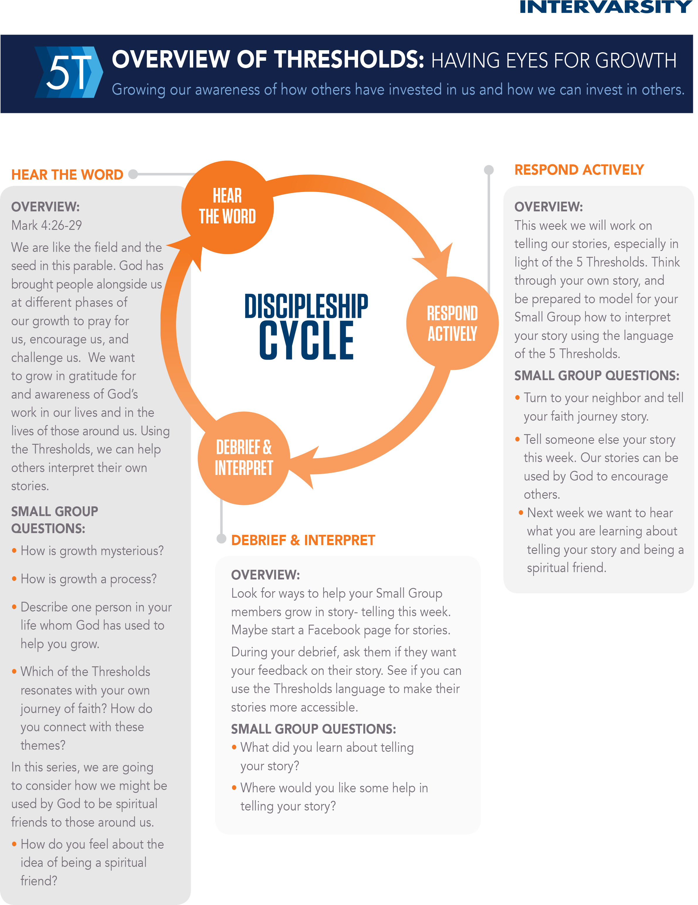

30 Second Vision Talk
Topic: Why should our community become a conversion community?
Larger Community Vision

Personal Story

Invitation

Reflection questions

Sunday 7:45 PM

100 Ideas for Fun Handout

- Go to the thrift store together
- Going to the gym
- Play sports together
- Frisbee Golf
- Ultimate Frisbee
- Euchre [Cards]
- Board Games
- Go to Movies or watch one at someone’s place
- Video Games
- Watching TV show regularly together
- Cooking/Baking together
- Apple orchard
- Visit other campuses
- Go to sporting events
- Go to Convocation events
- Trivia Nights
- Study together
- Hang out with other friends
- Go to local farmers market
- Visit a city for the weekend
- Go to a local park
- Stay up for the 2am happy hour at Steak n’ Shake
- 1/2 price apps at Applebee’s
- Take a trip to a state park
- Watch sports on TV
- Late night runs [Walmart, McDs, etc.]
- Grocery shopping together
- Bonfire
- Play music together
- Host an all-nighter
- Go to the hot tub/ pool at the gym
- Go to other campus events [cultural events and shows]
- Brunch after church
- Build things together [potato cannons]
- Hanging out and talking [question book]
- Watching the news together.
- Go on a road trip
- Concerts
- Listen to music together [no headphones]
- Go out for a “fancy” dinner.
- Go sledding in the winter
- Paint with Bob Ross
- Go to museums together
- Movie Marathons
- Celebrating holidays [dyeing eggs, carving pumpkins, Friendsgiving]
- Pot luck
- Go caroling
- Laser Tag
- Mini-golf
- Go grab coffee/tea/hot chocolate/cider/etc.
- Ice cream
- Paintball
- Cookout
- Star tipping
- Try a new restaurant
- Visit a dog shelter
- Volunteer together in the community
- Ice Cream Crawl
- Food eating challenges
- Host a party [hangout]
- Craft night
- Go ice skating
- Paint pottery
- Puzzle Night
- Run a 5K together
- Karaoke Night
- Spa Night
- Lego Night
- Go to the mall or shopping
- YouTube night
- Open mic [Poetry] night
- Do science experiments [Diet Coke & Mentos]
- Read the same book and talk about it.
- Watch cartoons on a Saturday Morning
- Go bowling
- Water balloon or snowball fight
- Nerf wars
- Have a Ramen night
- Paper airplanes contest off of a parking garage
- Office chair jousting
- Minute to win it challenges
- Trivia nights
- Play wally ball at the gym
- Play pool or ping pong in a dorm
- Do mad libs
- Eat breakfast at midnight
- Go on a picnic
- Go geocaching
- Yard Games
- Attend a local festival
- Pinterest Together
- Build a snowman
- Take a hike
- Play charades
- Go to the local arcade
- Jump on a trampoline
- Get into a friendly prank war
- Movie Marathon
- Go fishing together
- Plant a garden together

Monday 9 AM

Growing in Telling Your Story

Before:
What your life used to be like.
Back in high school…
When I was a freshman…

Problem:
I got confused between having a love-relationship with God and following a lot of rules…
I was looking for God without religion...
I was living under this burden...

During:
How did I encounter the real Jesus or the living God.
I bumped into this group of InterVarsity students…
Jesus came to life for me…
I had this powerful experience of God’s personal love for me….

After:
Life today.
My life is not perfect, but I am much less … than I used to be.
Jesus is teaching me to...

BRIDGE to the invitation.
How about you? Would you be interested in taking an adult look at Jesus for yourself? I’d love to look at Jesus with you?
How about you? Have you ever put God to the test, that he would reveal himself to you? I’d love to pray with you.
Have you ever thought about looking for God but leaving religion behind? Please come check out our community.

Luke 15:11-32
¹¹ Then Jesus said, “There was a man who had two sons. ¹² The younger of them said to his father, ‘Father, give me the share of the property that will belong to me.’ So he divided his property between them. ¹³ A few days later the younger son gathered all he had and traveled to a distant country, and there he squandered his property in dissolute living. ¹⁴ When he had spent everything, a severe famine took place throughout that country, and he began to be in need. ¹⁵ So he went and hired himself out to one of the

citizens of that country, who sent him to his fields to feed the pigs. ¹⁶ He would gladly have filled himself with the pods that the pigs were eating; and no one gave him anything. ¹⁷ But when he came to himself he said, ‘How many of my father’s hired hands have bread enough and to spare, but here I am dying of hunger! ¹⁸ I will get up and go to my father, and I will say to him, “Father, I have sinned against heaven and before you; ¹⁹ I am no longer worthy to be called your son; treat me like one of your hired hands.”’ ²⁰ So he set off and went to his father. But while he was still far off, his father saw him and was filled with compassion; he ran and put his arms around him and kissed him. ²¹ Then the son said to him, ‘Father, I have sinned against heaven and before you; I am no longer worthy to be called your son.’ ²² But the father said to his slaves, ‘Quickly, bring out a robe—the best one—and put it on him; put a ring on his finger and sandals on his feet. ²³ And get the fatted calf and kill it, and let us eat and celebrate; ²⁴ for this son of mine was dead and is alive again; he was lost and is found!’ And they began to celebrate. ²⁵ “Now his elder son was in the field; and when he came and approached the house, he heard music and dancing. ²⁶ He called one of the slaves and asked what was going on. ²⁷ He replied, ‘Your brother has come, and your father has killed the fatted calf, because he has got him back safe and sound.’ ²⁸ Then he became angry and refused to go in. His father came out and began to plead with him. ²⁹ But he answered his father, ‘Listen! For all these years I have been working like a slave for you, and I have never disobeyed your command; yet you have never given me even a young goat so that I might celebrate with my friends. ³⁰ But when this son of yours came back, who has devoured your property with prostitutes, you killed the fatted calf for him!’ ³¹ Then the father said to him, ‘Son, you are always with me, and all that is mine is yours. ³² But we had to celebrate and rejoice, because this brother of yours was dead and has come to life; he was lost and has been found.’”

Monday 4 PM

Luke 14:12-24
¹² Then Jesus said to his host, “When you give a luncheon or dinner, do not invite your friends, your brothers or sisters, your relatives, or your rich neighbors; if you do, they may invite you back and so you will be repaid. ¹³But when you give a banquet, invite the poor, the crippled, the lame, the blind, ¹⁴ and you will be blessed. Although they cannot repay you, you will be repaid at the resurrection of the righteous.” ¹⁵When one of those at the table with him heard this, he said to Jesus, “Blessed are those who will eat at the feast in the kingdom of God.” ¹⁶Jesus replied: “A certain man was preparing a great banquet and invited many guests. ¹⁷ At the time of the banquet he sent his servant to tell those who had been invited, ‘Come, for everything is now ready.’ ¹⁸“But they all alike began to make excuses. The first said, ‘I have just bought a field, and I must go and see it. Please excuse me.’ ¹⁹“Another said, ‘I have just bought five yoke of oxen, and I’m on my way to try them out. Please excuse me.’ ²⁰“Still another said, ‘I just got married, so I can’t come.’ ²¹“The servant came back and reported this to his master. Then the owner of the house became angry and ordered his servant, ‘Go out quickly into the streets and alleys of the town and bring in the poor, the crippled, the blind and the lame.’ ²²“‘Sir,’ the servant said, ‘what you ordered has been done, but there is still room.’ ²³“Then the master told his servant, ‘Go out to the roads and country lanes and compel them to come in, so that my house will be full. ²⁴ I tell you, not one of those who were invited will get a taste of my banquet.’”

Prayer Mapping Worksheet

First Threshold Discipleship Cycle
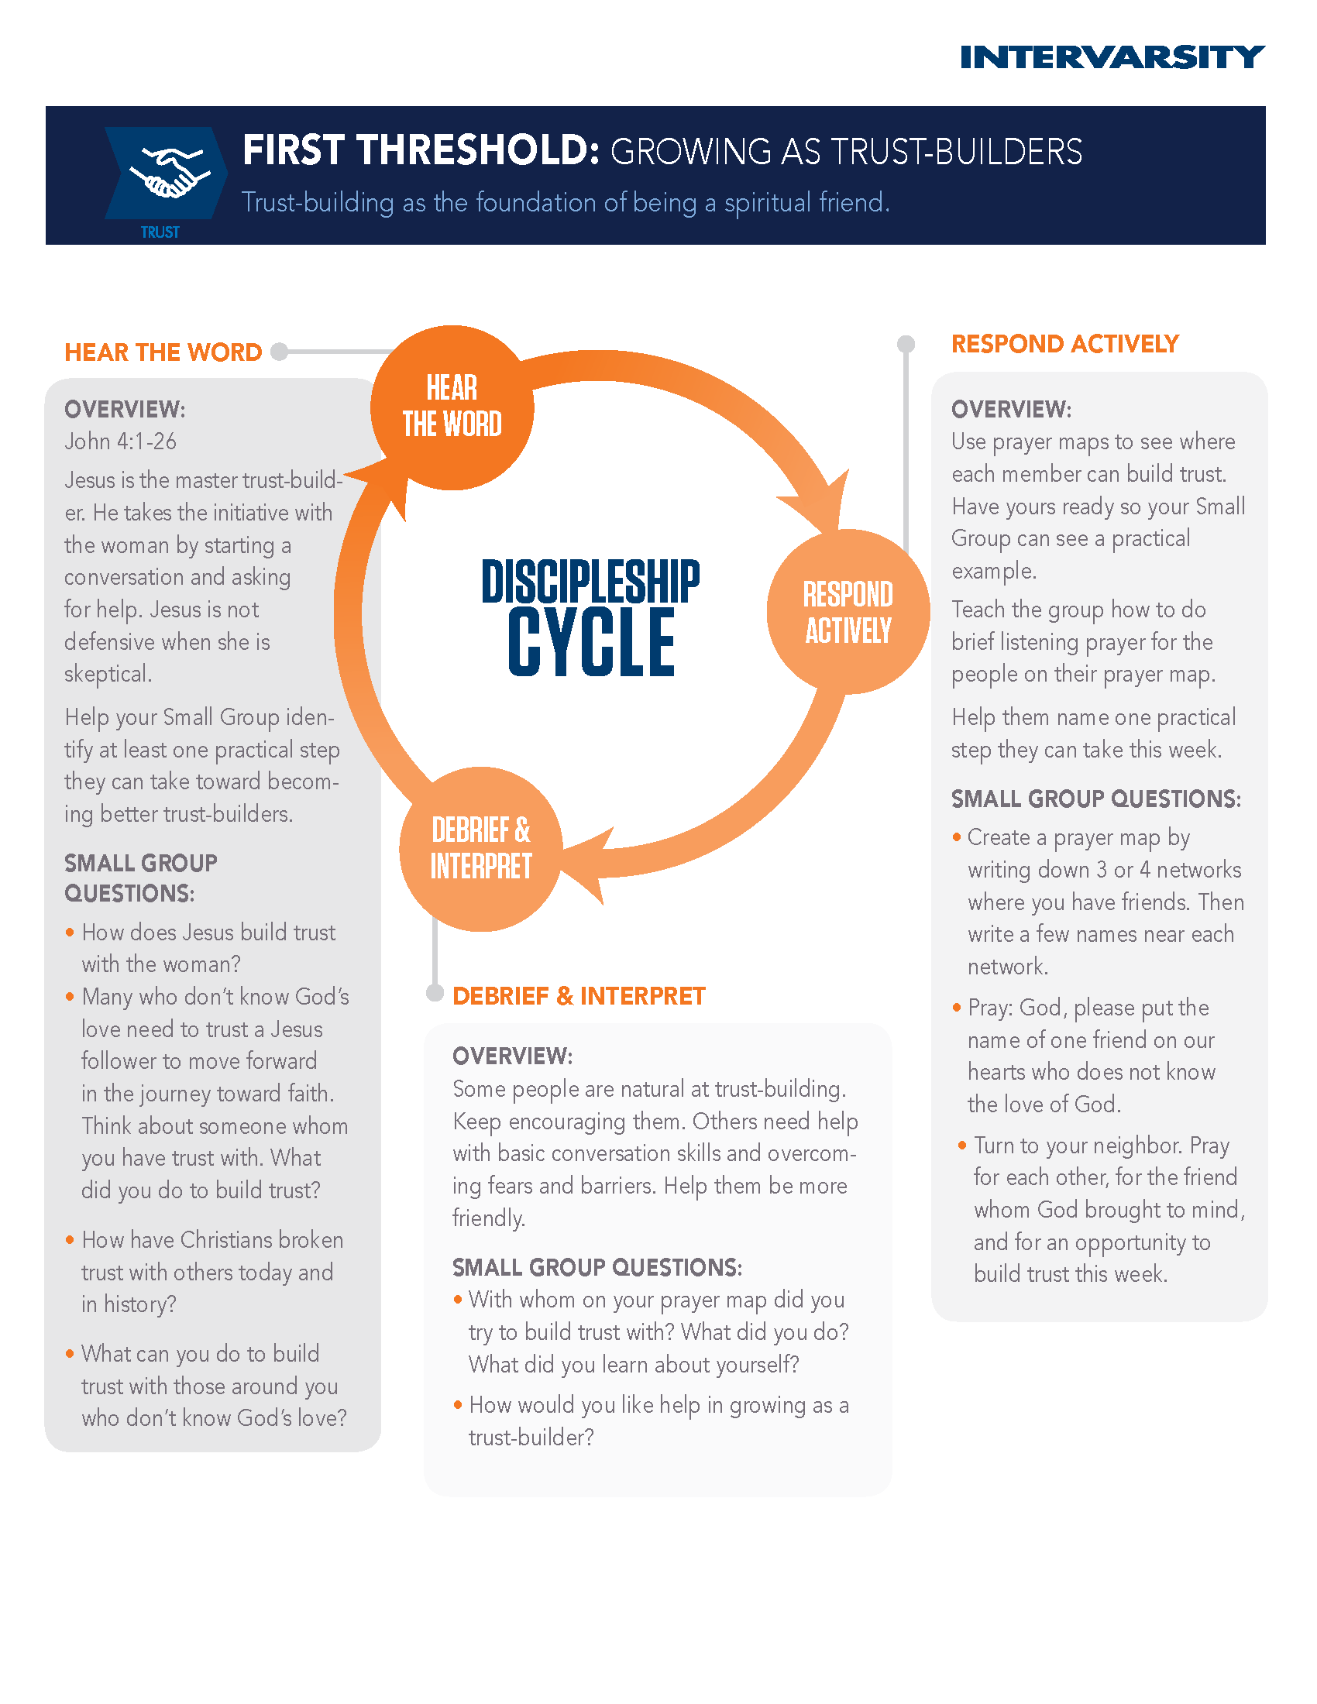

Tuesday 9 AM

Rate Yourself as a Risk Taker
  - For each category pick the statement that fits your preferences best.
Physical world
- Low-intensity activity such as a walk in the park or a stroll around a lake.
- Medium-intensity such as hiking in the hills, water skiing, working out at the gym.
- High-intensity activities such as bungee jumping, rock climbing, mountain biking, snow boarding.
.
Relationships
- I don’t really like meeting new people and I tend to avoid social situations.
- I sometimes initiate conversation as long as I know the person.
- I’m very outgoing and I like to meet new people.

Finances (imagine yourself as an investor, if you aren’t already)
- Conservative: If I were to invest my money in the market, I’d make low-risk choices, even if the opportunity for big gains is small.
- Medium: I would take some level of risk in the market while still being safe with my money.
- Risky: I would put my money in high-risk investments in order to maximize the possibilities of financial gain.

Career (imagine your future career preferences if you’re not currently in a career)
- I prefer a safe, quiet job that is predictable, orderly and conservative.
- I’d like a job that presents opportunities for success even if there is also some chance of failure.
- I’d love a high-risk job that rewards performance generously but also includes the risk of failure and loss of job (such as a sales job).

Scoring: Add together the numbers from all the categories and rate yourself as a risk-taker.
- Safe and secure: If you scored 4 or 5, you tend to be a conservative person who avoids risk.
- Moderate: If you scored 6-9, you are a medium risk taker. You will assume moderate risk for a chance at greater rewards.
- High-flyer: If you scored 10-12 you are a “go for it” kind of person who wants to score big rewards and is even willing to risk the possibility of utter failure in the process.

Share the results with your SG or a partner. Does this ring true with your personality? Why or why not? Do you think of yourself as a risk-taker?

Acts 16:11-15
¹¹ We set sail from Troas and took a straight course to Samothrace, the following day to Neapolis, ¹²and from there to Philippi, which is a leading city of the district of Macedonia and a Roman colony. We remained in this city for some days. ¹³ On the sabbath day we went outside the gate by the river, where we supposed there was a place of prayer; and we sat down and spoke to the women who had gathered there. ¹⁴ A certain woman named Lydia, a worshiper of God, was listening to us; she was from the city of Thyatira and a dealer in purple cloth. The Lord opened her heart to listen eagerly to what was said by Paul. ¹⁵ When she and her household were baptized, she urged us, saying, “If you have judged me to be faithful to the Lord, come and stay at my home.” And she prevailed upon us.

Wednesday 9 AM

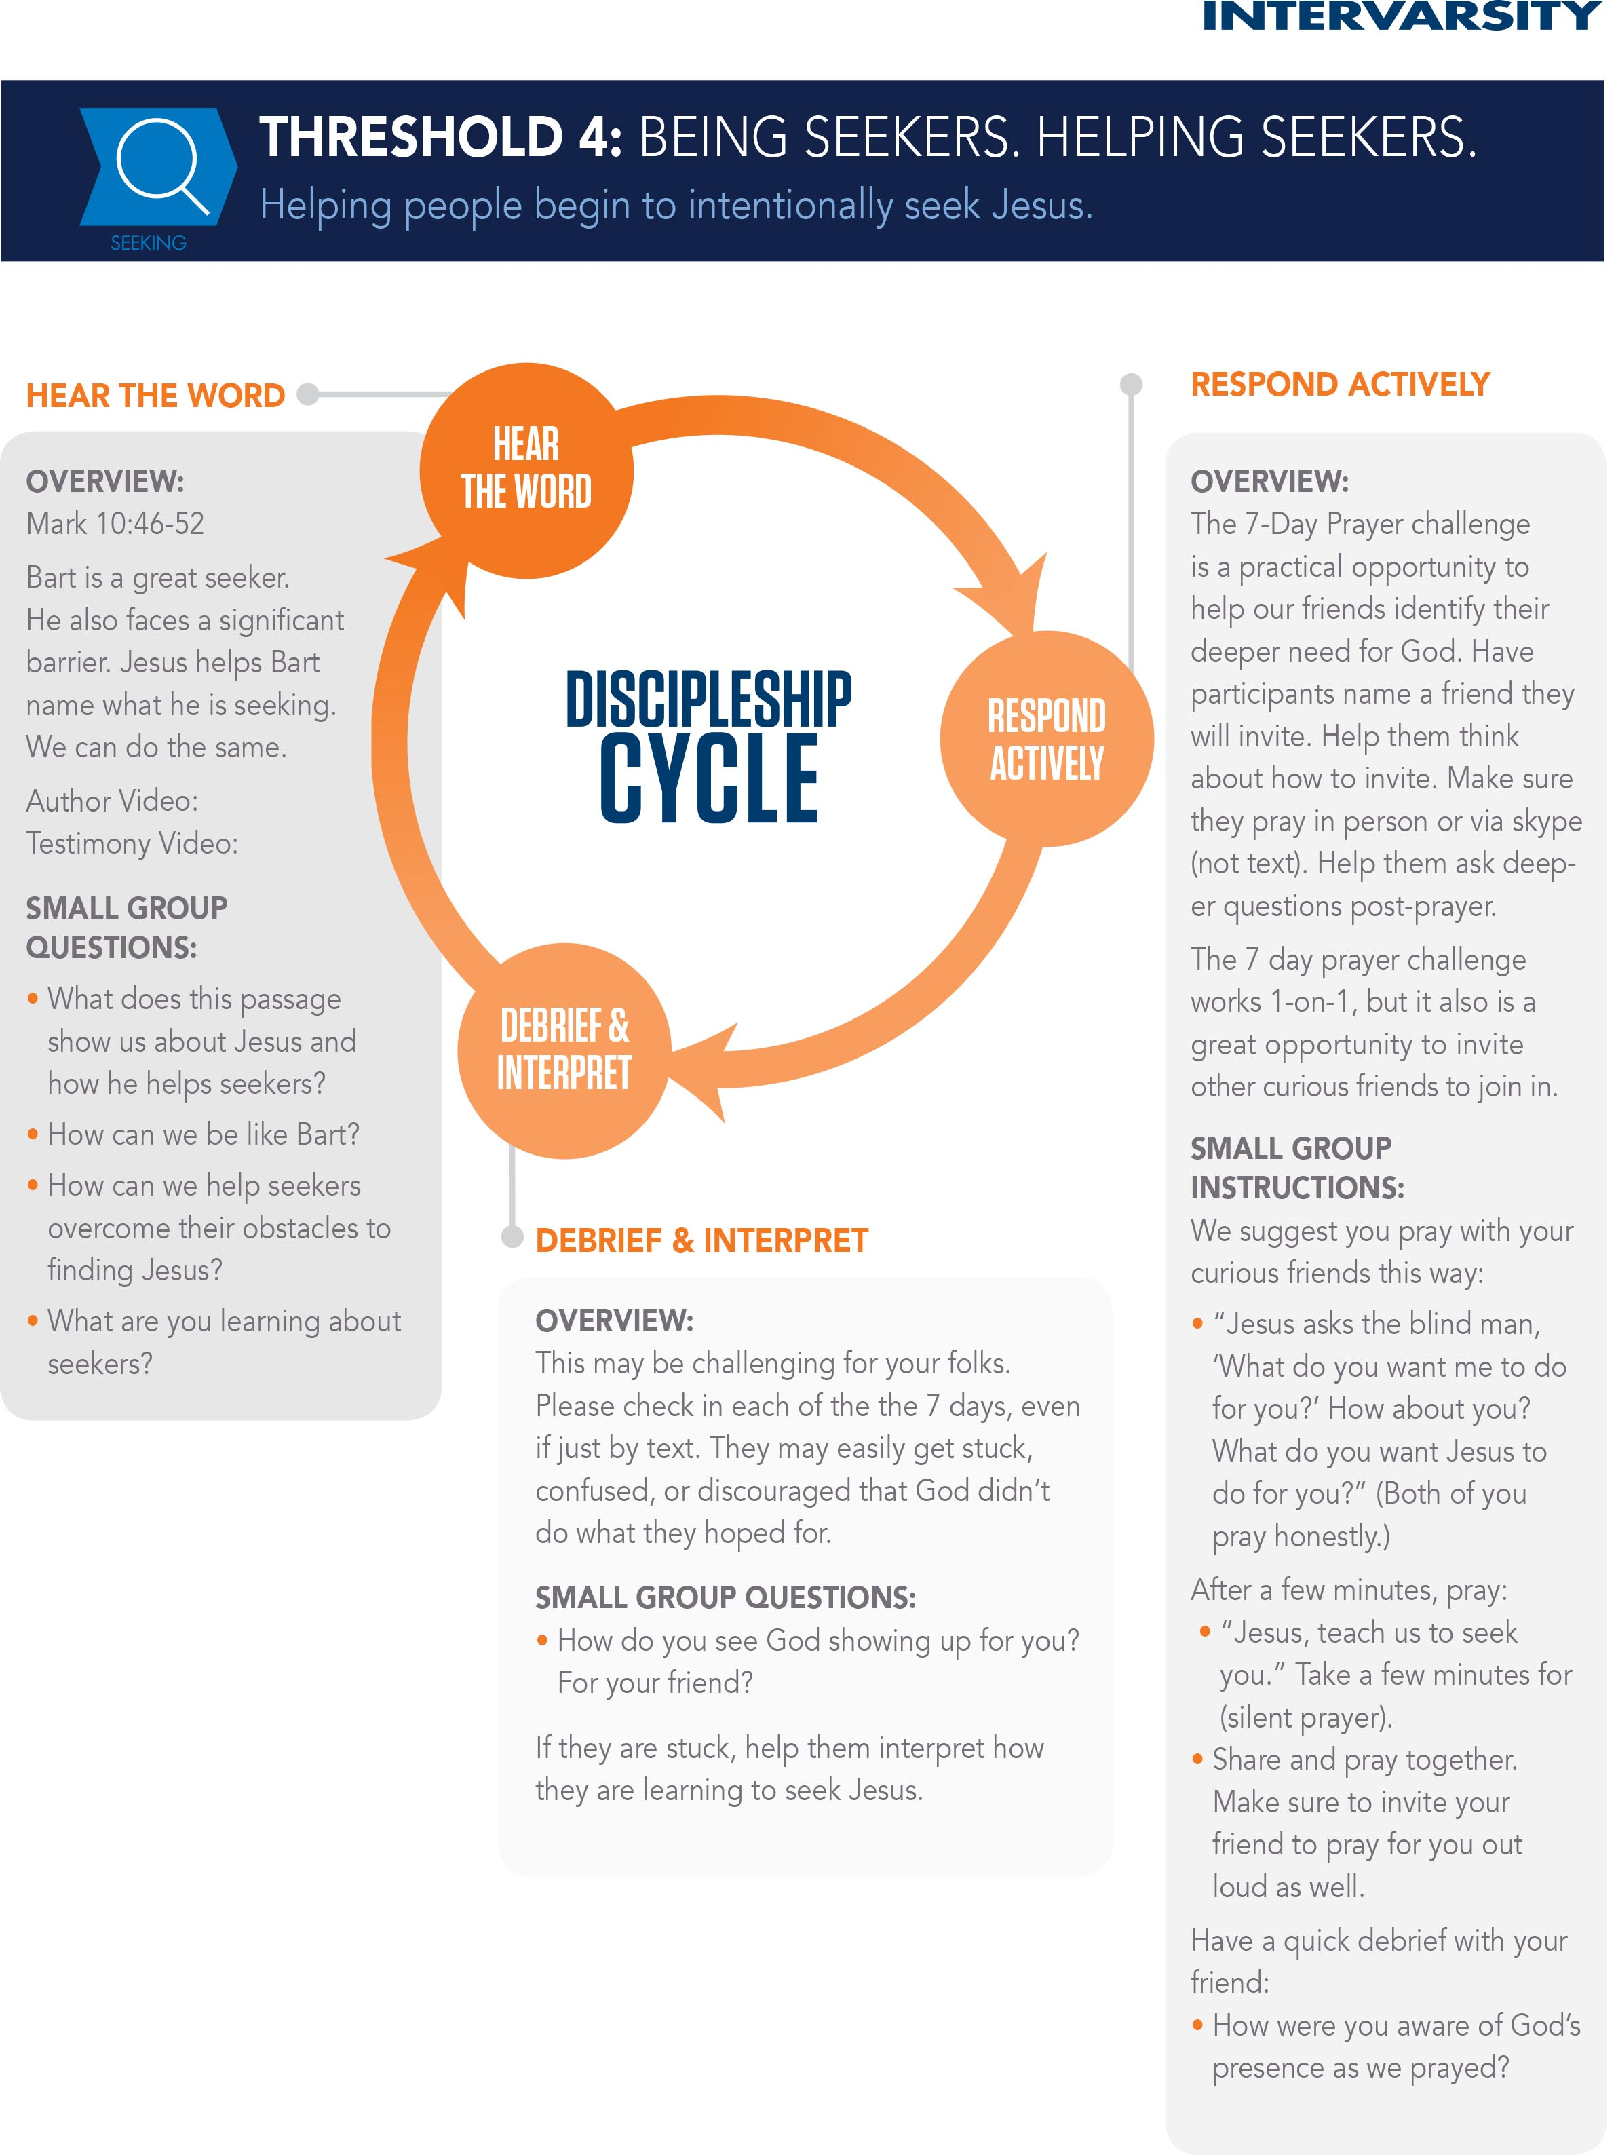
Threshold 4: Being Seekers, Helping Seekers

Mark 10:46-52

⁴⁶ They came to Jericho. As he and his disciples and a large crowd were leaving Jericho, Bartimaeus son of Timaeus, a blind beggar, was sitting by the roadside. ⁴⁷ When he heard that it was Jesus of Nazareth, he began to shout out and say, “Jesus, Son of David, have mercy on me!” ⁴⁸ Many sternly ordered him to be quiet, but he cried out even more loudly, “Son of David, have mercy on me!” ⁴⁹ Jesus stood still and said, “Call him here.” And they called the blind man, saying to him, “Take heart; get up, he is calling you.” ⁵⁰ So throwing off his cloak, he sprang up and came to Jesus. ⁵¹ Then Jesus said to him, “What do you want me to do for you?” The blind man said to him, “My teacher, let me see again.” ⁵² Jesus said to him, “Go; your faith has made you well.” Immediately he regained his sight and followed him on the way.

Author Video

Spiritual Conversations Video

This week will . . .

Influence Plan
 | VISION  What tool from this week would you like to use to influence your chapter towards evangelism?  How many people do you want to train/ coach?  With what students would you like to use this tool? | PEOPLE  Who needs to lead/train/coach each part of this plan with you?  What key skills need training for this part of the plan? | STRUCTURE  How will you recruit students to do this training with you?  When will you begin training? When will you end?  How will you present your idea to your staff or leadership team?
My plan:

Wednesday 4 PM

The Big Story Booklet

Gospel Pieces Handout
“For in the gospel the righteousness of God is revealed” Romans 1:17

Below you will find 8 key components of the gospel. In parentheses are other ways of describing the concepts. Then for each piece we have included some scripture that helps to unpack the concept

Gospel pieces
  - God (designer, creator, love, perfect) – Acts 3:13; Romans 1:20; Nehemiah 9:6
  - Man (created by God, similar in that we are made for relationship and designed for good) – Acts 3:13, 25; Genesis 1:27-31; Psalms 8:3-8
  - Sin (brokenness, damage, evil, wrong, personal guilt) – Acts 3:14, 26; Romans 1:24-25, 3:10, 23, 5:12; Colossians 1:21; Ecclesiastes 7:20; 1 John 1:8
  - Death (physical and spiritual death, consequence, loneliness, rejection, separation from what is good forever, judgment) – Acts 3:23; Romans. 6:23; Isaiah 53:1-12; 1 John 2:2; Hebrews 9:22
  - Jesus’ life (God came as a man, identified with us, shared in our pain and sufferings, lived a perfect life) – Acts 3:18,22,26; Isaiah 23:9; 1 John 3:5; John 1; Colossians 1:15-20
  - Jesus’ death (crucifixion, owned our brokenness and death, took our punishment) – Acts 3:13,15; Romans 5:6; 2 Corinthians 5:21; John 19:30
  - Jesus’ resurrection (raised from the dead, conquered death, overcame the brokenness and death) – Acts 3:15; Romans 6:8-10; 1 Corinthians 15:3-8,12-19; Luke 24:6-7
  - Invite a response
    - Repent (believe and turn from our way to his way, own our brokenness, ask for forgiveness) Acts 3:19; Isaiah 30:15; 1 John 1:9; Romans 10:9-13; Mark 1:15; Acts 17:30
    - Follow (live through his power, lordship, be his hands and feet, sent together to heal) Acts 3:6-10; Ephesians 2:8-9; Matthew 28:19-20; Acts 4:32-35
Other resources: The Big Story gospel presentations IVP, Basic Christianity by John Stott, http://evangelism.intervarsity.org/how/conversation/how-not-speak-christianese, http://evangelism.intervarsity.org/how/gigs/significance-jesus-death-cross, Erasing Hell by Francis Chan, Beyond Awkward by Beau Crosetto,

Thursday 9 AM

Luke 16:1-15
¹ Then Jesus said to the disciples, “There was a rich man who had a manager, and charges were brought to him that this man was squandering his property. ² So he summoned him and said to him, ‘What is this that I hear about you? Give me an accounting of your management, because you cannot be my manager any longer.’ ³ Then the manager said to himself, ‘What will I do, now that my master is taking the position away from me? I am not strong enough to dig, and I am ashamed to beg. ⁴ I have decided what to do so that, when I am dismissed as manager, people may welcome me into their homes.’ ⁵ So, summoning his master’s debtors one by one, he asked the first, ‘How much do you owe my master?’ ⁶ He answered, ‘A hundred jugs of olive oil.’ He said to him, ‘Take your bill, sit down quickly, and make it fifty.’ ⁷ Then he asked another, ‘And how much do you owe?’ He replied, ‘A hundred containers of wheat.’ He said to him, ‘Take your bill and make it eighty.’ ⁸ And his master commended the dishonest manager because he had acted shrewdly; for the children of this age are more shrewd in dealing with their own generation than are the children of light. ⁹ And I tell you, make friends for yourselves by means of dishonest wealth so that when it is gone, they may welcome you into the eternal homes. ¹⁰ “Whoever is faithful in a very little is faithful also in much; and whoever is dishonest in a very little is dishonest also in much. ¹¹ If then you have not been faithful with the dishonest wealth, who will entrust to you the true riches? ¹² And if you have not been faithful with what belongs to another, who will give you what is your own? ¹³ No slave can serve two masters; for a slave will either hate the one and love the other, or be devoted to the one and despise the other. You cannot serve God and wealth.” ¹⁴ The Pharisees, who were lovers of money, heard all this, and they ridiculed him. ¹⁵ So he said to them, “You are those who justify yourselves in the sight of others; but God knows your hearts; for what is prized by human beings is an abomination in the sight of God.

Lewin’s Force Field Worksheet

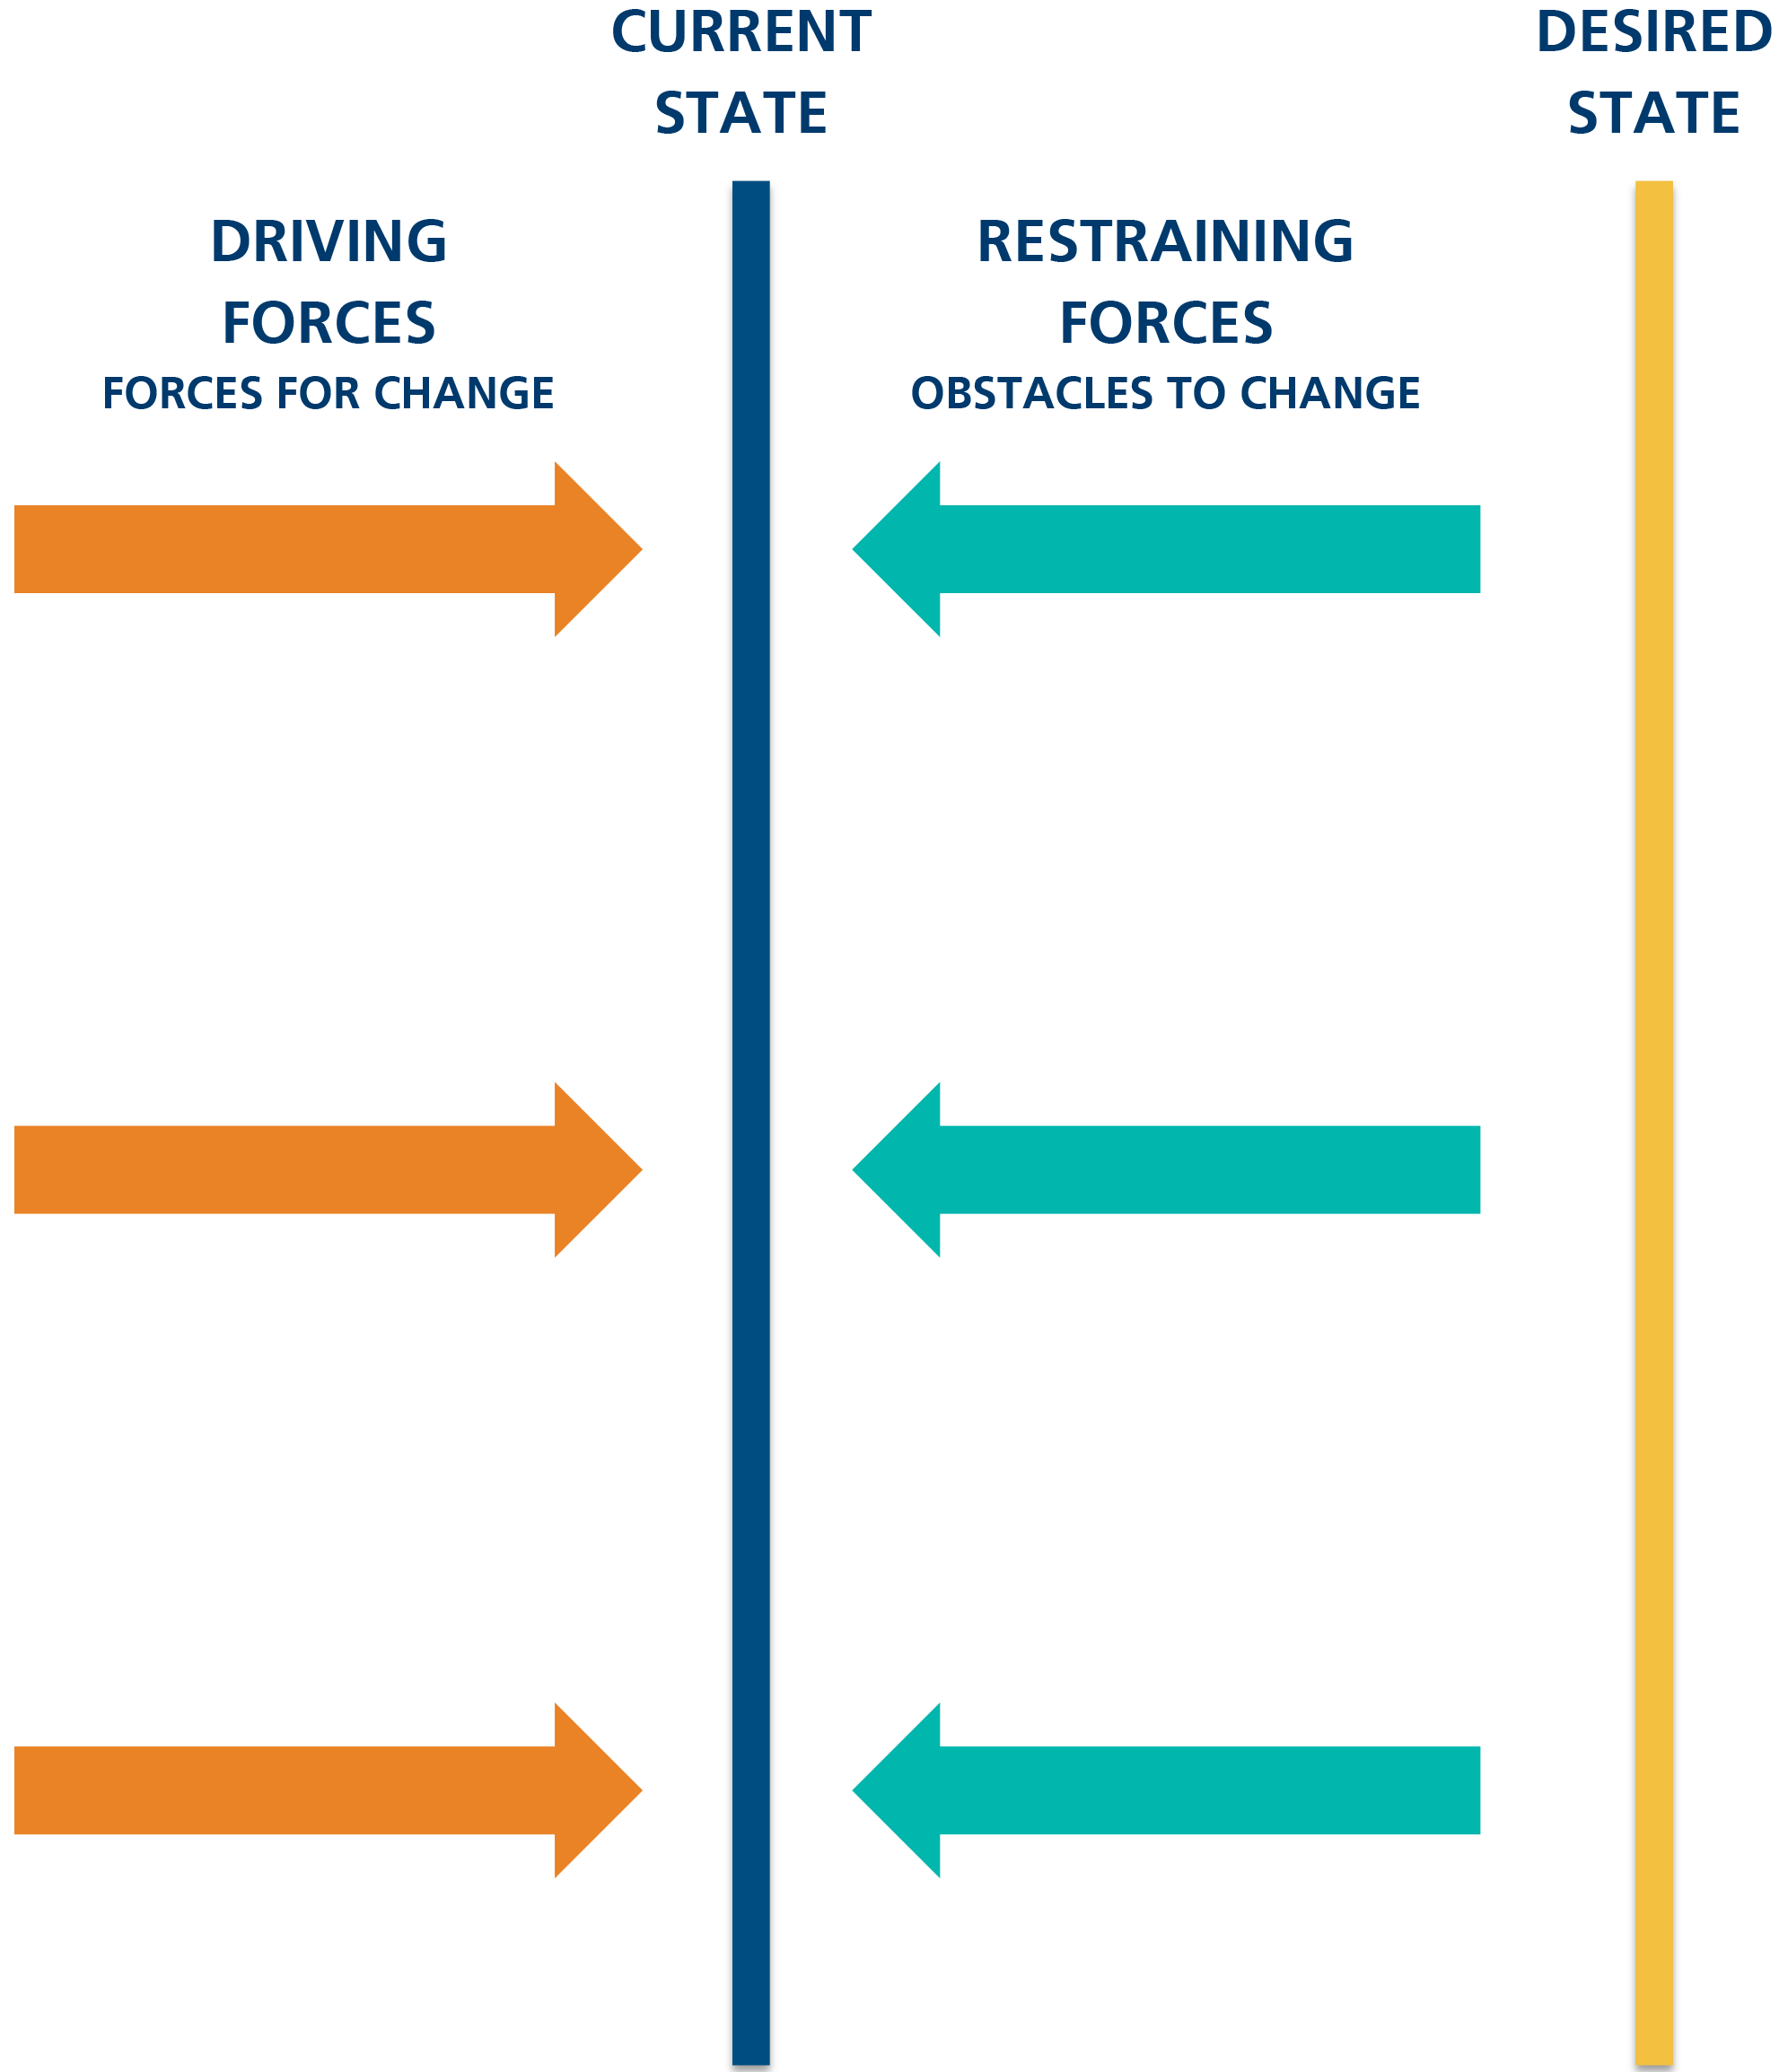

Grow Coaching Sheet for Conversion Communities

The GROW Model
Helping your community grow to a conversion community.

Shrewd influencers work with others to achieve their best. As you seek to partner with your small group leader, this model will typically help solve problems, make better decisions and train new skills. GROW is a proven model that emphasizes:
Goal Reality Options Will

How to Use the GROW Tool
This resource is intended to spark a conversation about your small group between you and the leadership of your small group.

Establish the Goal | Define and agree on a quantitative goal. Focus on specific, measurable and realistic outcomes. Explore questions such as:  What is your evangelistic goal for your small group over the year?  How many GIGs would you like to see begin through small group members?  How many people do you want to have made decisions to follow Jesus who are connected with your small group?  How many outreach events will your small group host to build trust with non-Christians on campus?  You do not have to set numerical goals for each of these questions. This is hopefully a helpful start as you think about what kinds of goals you will set.
Examine Current Reality | Assess the current situation. Highlight any gaps. Pursue a descriptive summary rather than a judgmental one. Include questions such as:  What is the gap between your goal and where you are today?  What are the barriers that may keep this goal from being met?
Explore the Options | Generate multiple alternative courses of action. Uncover assumptions and discern creative solutions. Invite the individual to consider:  What are some different things you could do to address the gap?  What are the benefits and downsides of each option?  Choose one and make a plan: Who? What? Where? How?  What kinds of specific events will your small group host?  What will you change about your meetings to make them hospitable to non-Christians?  Do your small group members need training in evangelism? If so, what training and when will it happen?
Establish the Will | Commit to a specific action. Identify the help needed along the way to stay with it. Useful questions include:  How likely is this option to succeed?  What could stop you moving forward? And how will you overcome it?  What kind of support and accountability will be helpful?  Who else do you need to get on board with this vision?  How can your staff support you?

Three Really Good Ways to be an Influencer
- Model a lifestyle of evangelism. Live it out!
- Nothing is more compelling than the stories you will gather as you begin to live out a lifestyle of evangelism within your own social circles.
- Pray!
- Consider gathering a few people in your chapter to begin praying that your chapter culture would embrace evangelism as a lifestyle as it’s embodied through the community. Pray for specific people to know Jesus and for a shift in the culture of your chapter. Pray for unreached people groups on your campus and listen for God’s direction and where to go next.
- 30 second vision cast!
  - Do it often and persistently! Cast vision about what it could look like if your community truly became a witnessing community.

Thursday 4 PM

Evaluation Tri-Carbons

Recommendations for Further Reading and Study

InterVarsity Books
  - I Once Was Lost by Don Everts and Doug Schaupp
  - Beyond Awkward by Beau Crosetto
  - True Story by James Choung
  - Out of the Saltshaker by Rebecca Manley Pippert
  - Faith is Like Skydiving by Rick Mattson
  - Breaking the Huddle by Don Everts, Doug Schaupp, and Val Gordon [Release expected December 2017]

Network Mapping Articles
  - Where Has God Planted You?
    - http://www.releasetheape.com/planted-you/#.VwamUbRflXt
  - The Power of Network Mapping
    - http://studentsoul.intervarsity.org/power-network-mapping
  - Network Mapping – A Skill to Develop Relational Networks
    - http://collegiateministries.intervarsity.org/chapter-planting/network-mapping-skill-develop-relational-networks
  - Why Network Mapping is So Powerful
    - http://collegiateministries.intervarsity.org/blog/why-network-mapping-so-powerful

