Leadership Team
  - Leadership Team Student Handbook

Table of Contents
Optional Pre work exercises: 3
Vision Dreaming Exercise: 3
SWOT Analysis Grid 4
Leadership Track Schedule 3
Sunday 3
Retreat of Silence 3
5
Goal Setting 6
Overall Growth Goal (what you want for your 2016 AFR):_____________ 6
What is your Conversion Goal for the 2016 AFR: ____________ 6
What is your Fall 2015 NSO Contact Card Goal: ______________ 6
What is your 2016 JNSO contact card goal: ___________ 7
What is your goal for numbers of Leader of Leaders (LOL) for 2016 AFR:_________ 7
What is your goal for number of Leaders for 2016 AFR: __________ 7
What is your goal for the number of Apprentices for 2016 AFR: 7
What is your goal for number of SGs for 2016 AFR: _________ 7
Monday 8
Quiet Time (9am-9:30am) 8
Manuscript (9:30am-10:45am) 8
Tuesday 9
Quiet Time (9am-9:30am) 9
Manuscript (9:30am-10:45am) 9
Ways of Dealing with Conflict 10
Conflict Resolution Case studies 12
Thumbs Down for Small Group 12
Roommate “Bonding” 12
Email Vent Session 13
Resolving Conflict 14
Wednesday 16
Quiet Time (9am-9:30am) 16
NSO Example: 17
Follow-up Example 18
Small Groups Multiplication Example 19
Missional multi-ethnicity on your campus 21
Missional Multi-ethnicity: Personal Reflection 22
Cultural Gifts Hedgehog Activity 23
Step 1: Understanding your passions 24
Step 2: Understanding Your Unique Cultural Gifts 24
Step 3: Understanding the Needs of your chapter and your campus 24
Step 4: Assessing the Overlap 24
Determine 2 concrete next steps to lead in mission in the fullness of your identity. 24
Developmental Pathway 25
Development Pathway 27
Thursday 29
Quiet Time (9am-9:30am) 29
Manuscript (9:30am-10:45am) 29
30-60 Second Vision Worksheet 30
Appendix 31
Situation Behavior Grid 31
CFW Large Group Observations 45

Optional Pre work exercises:

Vision Dreaming Exercise:

Imagine you are hosting a senior night in 5 years. Someone who graduated this year returns to the chapter and hears a senior give testimony about how the chapter has grown during their past four years. They write a letter to one of their peers who wasn’t able to be at the event. This alumnus describes the fruit of the decisions made at CFW this year. What would they write?

Give them time to write letter and then take turns reading them to each other. If not enough time during Sunday evening session another option is to sprinkle them throughout the week.

Debrief each letter:
What did you hear?
What are you learning about yourself? The chapter? The campus? God?
What are next steps?

SWOT Analysis Grid
NSO
Strengths | Opportunities
Weaknesses | Threats

Follow Up
Strengths | Opportunities
Weaknesses | Threats

Multiplying Small Groups
Strengths | Opportunities
Weaknesses | Threats

Any other Driver you want to evaluate before planning at CFW (realize time will likely be your limiting factor!)
Strengths | Opportunities
Weaknesses | Threats

Leadership Track Schedule

Time\Day | Sun | Mon | Tue | Wed | Thur
8:15am | Breakfast | Breakfast | Breakfast | Breakfast | Breakfast
9:00am-12:15pm | Before CFW:  Staff To do list Before CFW  SWOT Analysis  At CFW  ROS Guide  Chapter Staff Meeting | FOCUS ON GOD  Quiet Time  (30 min)  Manuscript  (75 min)  Break (15 min)  STRUCTURE  Planning / Team building (75 min) | FOCUS ON GOD  Quiet Time  (30 min)  Manuscript  (75 min)  Break (15 min)  PEOPLE  Conflict Resolution (75min) | FOCUS ON GOD  Quiet Time  (30 min)  STRUCTURE  Planning  (60 min)  Break (15 min)  Peer Edit Plans  (90 min) | FOCUS ON GOD  Quiet Time  (30 min)  Manuscript  (75 min)  Break (15 min)  STRUCTURE  Planning / Wrap-up (75 min)
12:30pm-4:00pm | Lunch - Break | Lunch - Break  Track Staff Meeting (1:15pm) | Lunch - Break | Lunch - Break  Track Staff Meeting (1:15pm) | Lunch - Break
4:00pm-6:15pm | VISION  Chapter Growth Strategy  (60 min)  Break (15 min)  Goal Setting (60 min) | STRUCTURE  Planning  (60 min)  Break (15 min)  Planning (60 min) | FREE TIME | PEOPLE  ME (white / soc)  (60 min)  Break (15 min)  Development Pathway (60 min) | VISION  Prayer (60 min)  Break (15 min)  Casting Vision  (60 min)
6:30pm | Dinner | Dinner | Dinner | Dinner | Dinner
7:30pm-9:15pm | STRUCTURE  VSP Planning Training Module (60 min)  Break (15 min)  Planning / Team building / Affiliation (30 min) | Plenary | Chapter Time | Plenary | Plenary
9:30pm-10:45pm | Chapter Time | Chapter Time |  | Chapter Time | Chapter Time

Sunday

Retreat of Silence
Arrival and settling in:
Settling in: Walk, explore, observe surroundings, rest
Looking back: How am I entering the week?
- How have I arrived here? What do I feel gratitude for? What encouragements have come to me recently? What weariness do I feel? What burdens weigh on me? What would I like to bring to Jesus?
- How am I doing emotionally? What am I angry/mad about? Sad about? Anxious about? Glad about?
  - Jesus’ Invitation: (Matthew 11:28-30) Meditate on Jesus’ invitation, and how you want to respond to him:
  - Arrival prayer: What do you want God to do for you? (consider journaling or even praying out loud)
Looking Back:
Personal:
- How has God met you this past academic year? Consider these few events to refresh your memory: new student outreach, first large group, small group, mid-terms, Cross Training, new friends, road trips, Winter Conference, spring break, finals, CFW.
- What did you learn about God and about yourself?
Ministry:
- How have you seen God work through the ministry of InterVarsity on your campus? Did anyone become a Christian this year? Did you, or someone you know, make significant Lordship decisions?
- What have been the ups and downs of your ministry this past year?
Looking Forward:
Personal:
- In what ways do you hope to meet God this summer? This next school year?
- What experiences, relationships and decisions will draw you closer to Jesus? And which ones will draw you further away?
Ministry:
- Where do you hope to see God at work through the ministry of InterVarsity on your campus next year? Who can you help draw closer to Jesus?
- What opportunities and challenges await you?
During this week at CFW we are going to be spending time daily in the Exodus. Prepare your hearts and minds now by reading Exodus 1-18 to acquaint yourself with the story of Exodus.

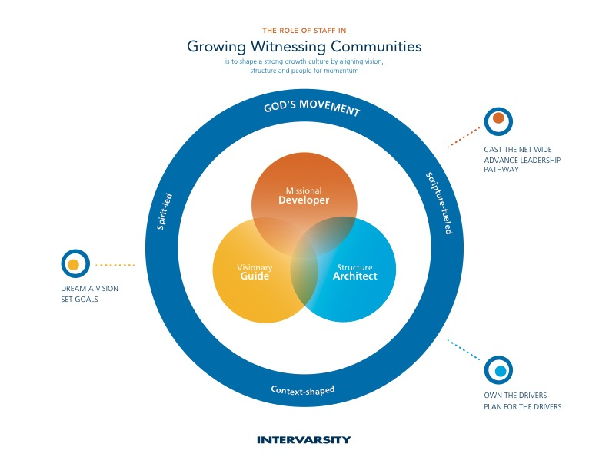
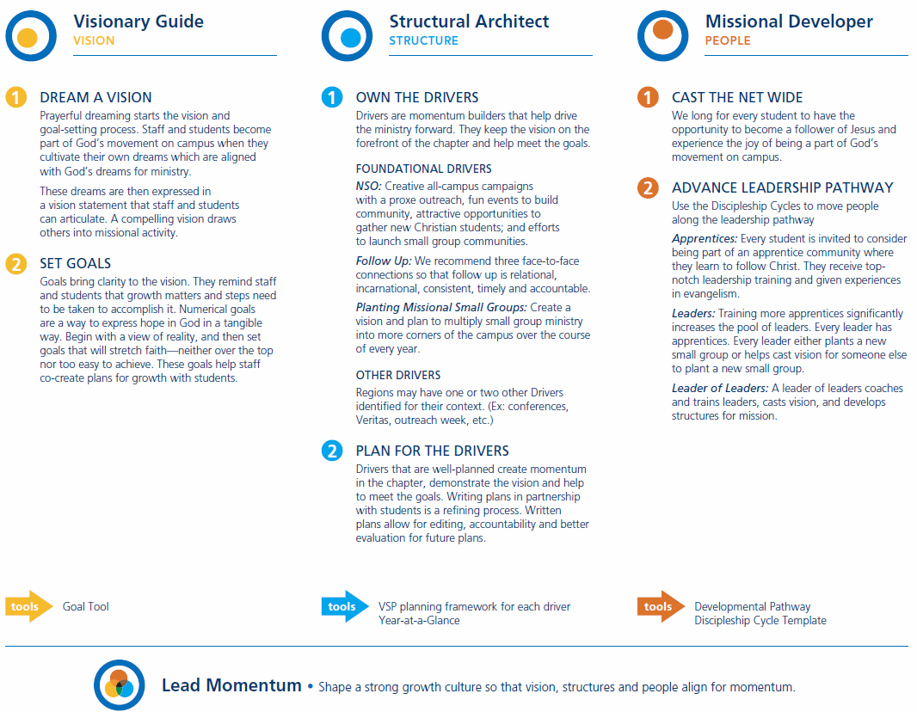

Goal Setting
This document provides a general rule of thumb for setting growth goals in our cohort.
You are free to deviate from these goals, but you ought to have a strong reason why and your AD and your Coach (or Lead Coach if your coach is on sabbatical) will need to sign off on the goal.

Overall Growth Goal (what you want for your 2016 AFR):_____________
If deviating from rule of thumb, what factors lead you to choose that goal?
Overall Growth Rule of Thumb
Moderate Growth Goal:
Chapters < 100 → Grow chapter by 10 students
Chapters > 100 → Grow chapter by 10%

Aggressive Growth Goal:
Chapters < 100 → Grow chapter by 20 students
Chapters > 100 → Grow chapter by 20%

What is your Conversion Goal for the 2016 AFR: ____________
If deviating from rule of thumb, what factors lead you to choose that goal?
Conversion Rule of Thumb
If history of no conversions:
Aim for growth rate: 4% of overall number

If history:
Aim for growth rate: 8% of overall number

What is your Fall 2015 NSO Contact Card Goal: ______________
If deviating from rule of thumb, what factors lead you to choose that goal?
Fall NSO Rule of Thumb:
Take your Growth Gap and multiply by 10
(2016 AFR Overall Goal - 2015 AFR) + (2015 AFR*.25) = Growth Gap

Example:
Chapter 2015 AFR is 100
Goal is to grow chapter to 110 students on 2016 AFR

In general you can often assume a 25% attrition from AFR so you will lose 25 students by August 2015
(110 - 100) + (100*.25) = 35 Growth Gap

We need to grow by 35 students to reach 2016 AFR Goal.
Thus our NSO contact card goal is 35*10=350 contact card

What is your 2016 JNSO contact card goal: ___________
If deviating from rule of thumb, what factors lead you to choose that goal?
JNSO Rule of Thumb:
Same as Fall NSO contact card goal, re-calculate the Growth Gap by taking the difference between the FFR and the AFR goal.
Growth Gap = 2016 AFR Overall Goal - 2015 FFR Overall number

Example:
Chapter of 100 on FFR 2015
2016 AFR Goal is 110
Growth Gap: (110-100) = 10
JNSO Contact Card Goal: (110-100) * 10 = 100
We need 100 JNSO contact cards

What is your goal for numbers of Leader of Leaders (LOL) for 2016 AFR:_________
If deviating from rule of thumb, what factors lead you to choose that goal?
Number of Leader of Leader Rule of thumb
1 leader of leader for every 25 students in your overall growth goal. Round up.
(i.e. a chapter of 110 would need 5 LOLs)

What is your goal for number of Leaders for 2016 AFR: __________
If deviating from rule of thumb, what factors lead you to choose that goal?
Number of Leaders Rule of thumb
Rule of thumb is 1 student leader for every 5 students in your overall growth goal:
(ie a chapter of 100 would need 20 leaders)

What is your goal for the number of Apprentices for 2016 AFR:
If deviating from rule of thumb, what factors lead you to choose that goal?
Number of Apprentices Rule of thumb
1 apprentice for every leader

What is your goal for number of SGs for 2016 AFR: _________
If deviating from rule of thumb, what factors lead you to choose that goal?
Number of SG Rule of thumb
1 small group for every 10 students in chapter:
(ie a chapter of 100 needs 10 small groups)

Monday

Quiet Time (9am-9:30am)
Enter (5 minutes)
Spend a few minutes in silence before the Lord. Praise Him for His character. Confess the distractions and worries that keep you from fully worshipping him this morning. Thank Him for his gracious patience with you. Intercede on behalf of your family and your chapter.

Scripture Study (15 minutes)
Read Exodus 3 slowly a couple times through. Ask the Holy Spirit to speak to you through the reading of the text. Begin to mark up your manuscripts with observations you are making of key words, repetitions, cause and effect relationships, etc. Also write down a couple questions you have from the passage. (Your personal study of passage will help you later during communal manuscript time).

Respond (10 minutes)
Choose one of these two responses:
- Reflect on how God called you into leadership. Share your story with a co-leader later in the day.
- As you step into leadership, what questions are you still wrestling with? What questions are you asking God? Your staff? Your co-leaders? Share these questions with God during this time and with a fellow student leader sometime during the day.

Manuscript (9:30am-10:45am)
Study Exodus 3 in large group

Tuesday

Quiet Time (9am-9:30am)

Enter (5 minutes)
Spend a few minutes in silence before the Lord. Look around you and notice the beauty of God’s creation this morning. Give him thanks for being Creator. Quiet yourself by surrendering any thoughts or worries that may compete for your attention and heart today. Thank Jesus for being sufficient in His grace today and always!

Scripture Study (15 minutes)
Read Exodus 4 slowly a couple times through. Pay attention to the particular words and images that jump off the page. Use colored pencils to help bring these things to your attention and make connections in the passage.

Respond (10 minutes)
- Reflect on where you feel inadequate as a leader. Who or what might the Lord be providing for you? Share with a fellow leader today.
- Maybe you’re an Aaron for someone. Who might that be? What is God calling the two of you to do?

Manuscript (9:30am-10:45am)
Study Exodus 4 In large group

Ways of Dealing with Conflict

Avoidance  Description:  Does not move into situations of potential conflict  Withdraws from situations of actual conflict  May value both relationship and task  Driving attitude:  “Nothing good is accomplished by conflict.”  Strengths:  Use when issue is trivial/not important  Use when time is needed to think and pray  Use when time is needed for people to cool down  Use when danger is imminent  Use when relationships are too fragile for conflict  Weaknesses:  Issue(s) may not disappear  Often results in pent-up tension/frustration  Important things (growth in relationships, completion of tasks, etc.) may be sacrificed | Accommodation  Description:  Opposite of competing  Places high value on relationship; lower value on task  “gives in”/ denies own preferences and or sense of what is best or right in deference to others  Driving attitude:  “Peace at any price.”  Strengths:  Use when issue is not important to you, but important to others  Use to build up “love points” or trust  Use when you are wrong  Use when others need to learn through experiencing the consequences of their position/way  Weaknesses:  Important things related to task may be sacrificed  Others may take advantage of you, knowing that you will “give in”
Competition  Description:  Opposite of accommodation  Places high value on task (winning, moving ahead, etc.), lower value on relationships  Pursues/fights for own preferences and/or sense of what is best or right regardless of others  Driving attitude:  “Win at any cost.”  Strengths:  Use when issues is a biblical absolute  Use when a quick decision is needed (e.g. emergency)  Weaknesses:  Important things related to relationships may be sacrificed. Others may not be honest with you knowing that you will “fight” to win | Compromise  Description:  Values both relationship and task  Works for an expedient, mutually acceptable solution through giving some and getting some  Driving attitude:  “Get it settled—quickly.”  Strengths:  Use when expedient solution is needed because of time limitation  Use when temporary solution is needed for a complex issue  Use when at an impasse in a situation where issue is not very important to either party  Weaknesses:  Can short-cut a needed process of working through an issue  Parties may give up something important that they may regret later  Parties may feel suspicious regarding how much the other is really giving up  Can leave both parties ultimately unsatisfied because of what is given up

Collaboration

Description:
Values both relationship and task
Attempts to work with the other party to find a solution, which fully satisfies both of them

Driving attitude:
“Work it through—no matter what it takes.”

Strengths:
Each party “wins” because they are fully satisfied
Parties are able to learn from each other, find misunderstandings, merge insights, work through feelings, seek/receive forgiveness, etc. All of these can strengthen relationships and complete the task

Weaknesses:
Can often be very time consuming and emotionally draining
Sometimes no fully satisfying solution can be found

Conflict Resolution Case studies

Thumbs Down for Small Group
I’ve been part of a small group the last couple of years. It’s been something I have really liked, except this year things are different.

Most of the year was good, but lately I don’t really like going. I feel like it’s a waste of time. I’m also not a big fan of Eric. He talks ALL the time and often takes the group on a tangent. Last week, I was trying to share what’s been going on in my life. I had been really having a crummy week. I failed a test. My hours got cut at work and I really need the money. On top of all that, my younger brother (who is in high school) just found out his girlfriend is pregnant and he hasn’t told our parents yet. After telling the group these things, Eric just cracked a joke. It might have been his way to lighten the mood and make me laugh or something. But it made me angry. He then started talking about something that I don’t even remember. I wasn’t really listening.

I’m thinking about checking out a different small group. I’ve been talking to my roommate about it. He thinks that might be a good idea.

What do you think I should do?
What is a God honoring way of resolving this conflict?

Roommate “Bonding”
Help! My fears of getting stuck with a lame-o roommate came true. Let’s just say my roommate has a different personality than me.

She loves to go bed early and get up early. This is the complete opposite of me. Her idea of a fun Friday night is curling up with her blanket and reading a book. Mine is having a bunch of friends over to order pizza and watch a movie.

It’s caused a few awkward moments already and it’s just the 3rd week of school. I had a bunch of friends over the other night. It was a weeknight but I don’t have class on Friday so it wasn’t a big deal to me. I think my roommate just wanted to study. So she left to go the library for most of the night. When she got back she didn’t say anything to us and just got ready for bed.

The next day there was a letter on my desk. She told me it’s been really frustrating her how I don’t seem to be respecting her. She has a hard time sleeping because I’m always up later than her. She said she doesn’t really like my friends coming over all the time.

I’m frustrated because it seems like I have to change just because we’re different.

It’s going to be a long year.

What do you think I should do?
What is a God honoring way of resolving this conflict?

Email Vent Session
I just received an email from someone in the chapter. He’s not very excited about how things are going this year. A lot of things have changed in the last couple of years and he doesn’t like the changes. He doesn’t like how small groups are structured this year. He’s wondering why certain people are leaders and others aren’t. He is also worried that we’re getting too “cliquey”. They said that there are others who are thinking these things as well. He said that because I’m one of the current leaders that I should know what he and others are thinking.

What should I do?
What is a God honoring way of resolving this conflict?

Resolving Conflict

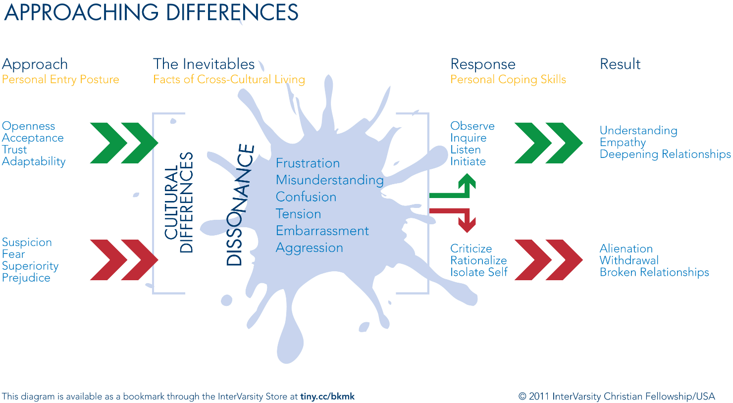

Wednesday

Quiet Time (9am-9:30am)
Enter (5 minutes)
Hear the invitation to be the Lord’s presence and with His people again today. Say yes to Him again this morning. Acknowledge the many ways you are tempted to wander in your relationship with Him. Name the people in your life in whom you find difficult to love and spend some a few minutes praying for them this morning.

Scripture Study (20 minutes)
Read as much of the story of Moses in Exodus 5-17 as you can. Often this is a familiar story. Reflect on what stands out to you. Pause anywhere that you sense the Lord speaking to you and share that with a fellow leader later in the day.

NSO Example:

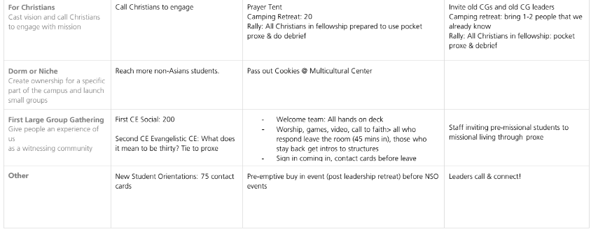
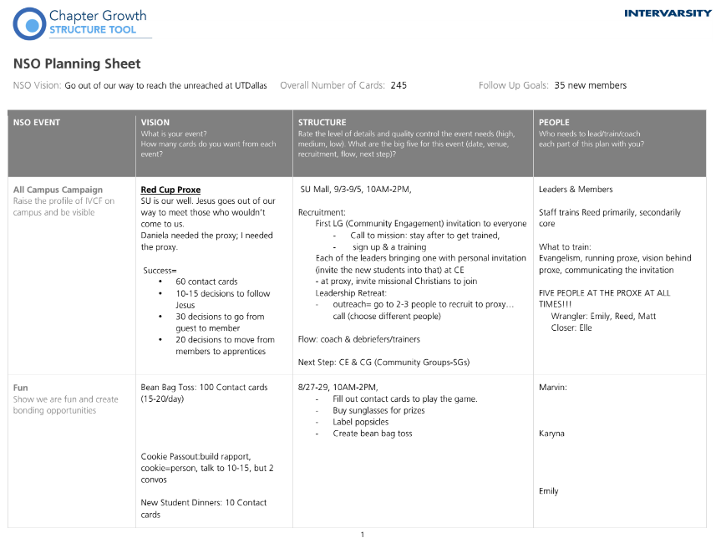

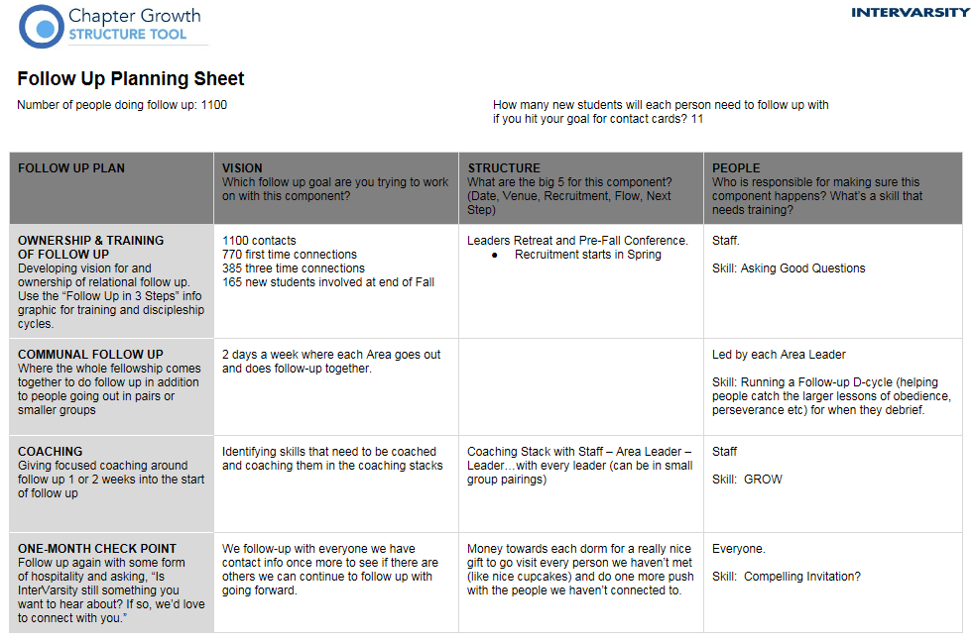
Follow-up Example

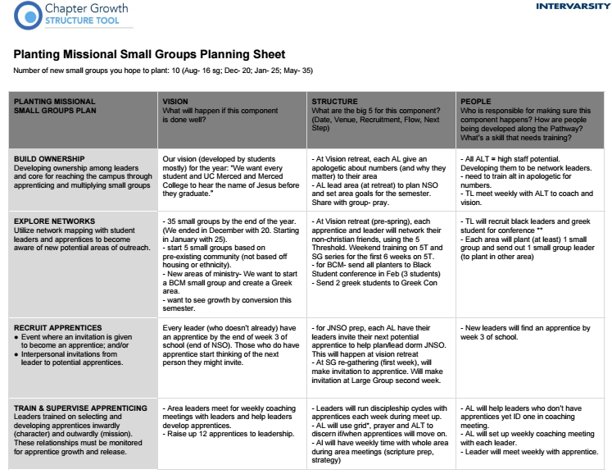
Small Groups Multiplication Example

Missional multi-ethnicity on your campus

Chapter Structure | Possible Barriers | Plans/Ideas
Small groups | -Most of our small group leaders live or lead on “west” campus, which is the lest diverse part  -Small group placement reflects who we have, not who we want to reach  - | -We’ll commit to doubling the amount of small groups at “east” campus by the end of next year  -We’ll place our most experienced SGLs and leaders who value multi-ethnicity on east campus
NSO training

NSO follow-up

Evangelism strategy

Large groups

Small groups

Leadership selection and training

Apprenticeship and discipleship

Conferences + recruitment

Missional Multi-ethnicity: Personal Reflection
The pursuit of multi-ethnicity will come with some costs to us individually and as a community – but the reward as a bigger picture of who God is and a deeper walk with Jesus. What next steps will I commit to as a leader in InterVarsity and as an apprentice of Jesus in order to better pursue real multi-ethnicity?

For your chapter, what people groups are present on campus but not present in your community? What might contribute to that

What places (if any) exist on your campus for partnership or new witness as you pursue multi-ethnicity?

What personal next steps is God calling you to as a result of this session? (Personal displacement? Cross-cultural mentoring or discipleship? Growing in your own ethnic identity? Learning opportunities?)

What will you have to sacrifice to pursue those next steps?

What spaces in your chapter do you have influence (think: meetings, structure, people, vision, etc)? How will you lead change in those places you have influence this fall?

Cultural Gifts Hedgehog Activity
Mission out of the Fullness of Our Identity
What are you deeply passionate about/what is life giving for you?
What is the need in your chapter/on campus?

Step 1: Understanding your passions
Think about what make you passionate on campus and in being a part of your chapter. What keeps you engaged as a part of this ministry? What inspires you about the vision of InterVarsity/your chapter?

Step 2: Understanding Your Unique Cultural Gifts
With this dimension your aim is to understand what your cultural/ethnic group or background brings to the body of Christ. First, be able to identify your ethnicity and cultural background, for some of us this is easy and for some of us we have multiple layers to our ethnic and cultural background. Embrace the fullness of your identity and how it has shaped you and the way you see God and others. There are obviously overlaps in our difference cultures. There is not a singular experience for any culture and this is not meant to perpetuate stereotypes. Example: a black student on the team might identify the unique cultural gift of Gospel music or a Bi-racial Black & Latin@ student might identify that they come from two cultures who bring the gift of celebration.

Step 3: Understanding the Needs of your chapter and your campus
To operate strategically and effectively in the mission field of your campus community, you must know your campus. What are the weaknesses of your campus community? What are the strengths? Who are the marginalized or unseen on your campus? Where is there concentrated areas of sin and brokenness on your campus? Where is there no witness on your campus?

Step 4: Assessing the Overlap
Where do you see overlap of all three circles? This is where the Lord is inviting you to partner with the Spirit for mission on campus. How can you apply this overlap practically to your leadership in your chapter and on the mission field?

Determine 2 concrete next steps to lead in mission in the fullness of your identity.

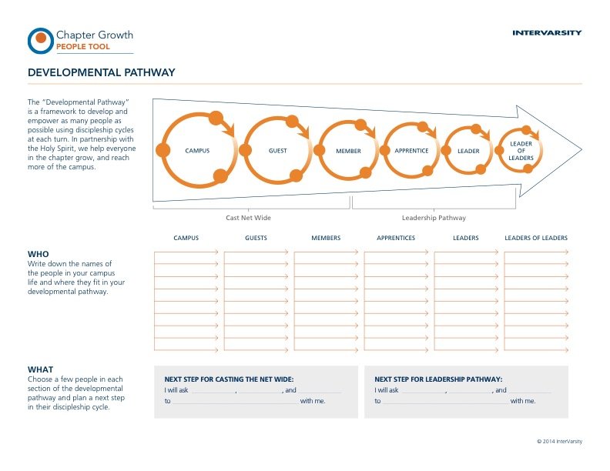
Developmental Pathway

Development Pathway
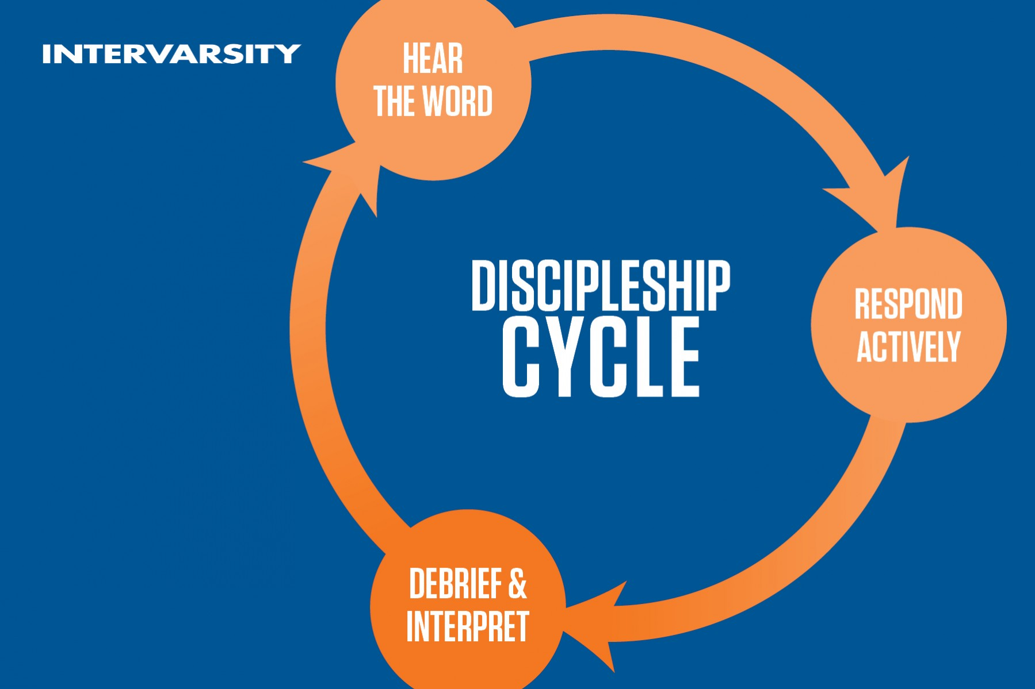
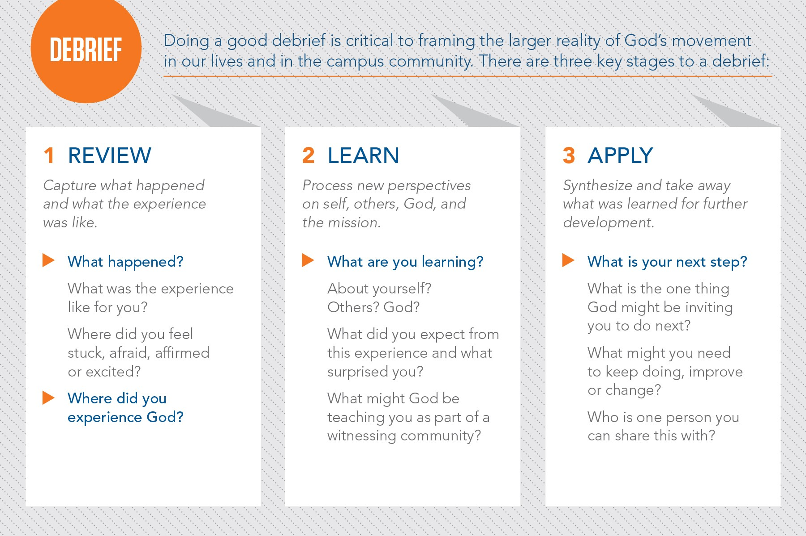

Thursday

Quiet Time (9am-9:30am)
Enter (5 minutes)
Reflect on the many ways the Lord has spoken to you this week already. Thank him for graciously and abundantly meeting you through His Word, His Spirit, His people and His creation.

Scripture Study (15 minutes)
Read Exodus 18 slowly a couple times through. Mark up your manuscript for one final time this week with key observations and questions you have from text.

Respond (10 minutes)
Commit to prioritizing time in the Word this summer. Make a plan for when this happen and what you will study. An idea for you to consider may be to continue your study in Exodus.

Manuscript (9:30am-10:45am)
Study Exodus 18 in large group

30-60 Second Vision Worksheet

Big Why
What is the big picture or idea that you are leading people to? Why should people care?

Personal Example
What personal example can you share that helps illustrate the Big Why?

Invitation
What are you asking people to do?

Appendix

Situation Behavior Grid
Observations | Example | Situation #1/Name | Situation #2/Name
Situation  Anchor in time or place | At the beginning of the session
Behavior  Observable Actions | When you came in late and were talking
Impact  What I felt and/or thought | I felt stressed that our time was short
My Perception of  the impact on others, the task or the work environment | It seemed like others were stressed too, and nervous that I was being disrespected
Reflection  Why did I pay attention to this?  What clues does it give about me? | I paid attention to this because I care how people on the team feel about how this time goes. I am realizing that time matters to me, especially when I feel like we don’t have enough time to accomplish our task.

Exodus 3 (ESV)
^{3:1} Now Moses was keeping the flock of his father-in-law, Jethro, the priest of Midian, and he led his flock to the west side of the wilderness and came to Horeb, the mountain of God. ² And the angel of the Lord appeared to him in a flame of fire out of the midst of a bush. He looked, and behold, the bush was burning, yet it was not consumed. ³ And Moses said, “I will turn aside to see this great sight, why the bush is not burned.” ⁴ When the Lord saw that he turned aside to see, God called to him out of the bush, “Moses, Moses!” And he said, “Here I am.” ⁵ Then he said, “Do not come near; take your sandals off your feet, for the place on which you are standing is holy ground.” ⁶ And he said, “I am the God of your father, the God of Abraham, the God of Isaac, and the God of Jacob.” And Moses hid his face, for he was afraid to look at God. ⁷ Then the Lord said, “I have surely seen the affliction of my people who are in Egypt and have heard their cry because of their taskmasters. I know their sufferings, ⁸ and I have come down to deliver them out of the hand of the Egyptians and to bring them up out of that land to a good and broad land, a land flowing with milk and honey, to the place of the Canaanites, the Hittites, the Amorites, the Perizzites, the Hivites, and the Jebusites. ⁹ And now, behold, the cry of the people of Israel has come to me, and I have also seen the oppression with which the Egyptians oppress them. ¹⁰ Come, I will send you to Pharaoh that you may bring my people, the children of Israel, out of Egypt.” ¹¹ But Moses said to God, “Who am I that I should go to Pharaoh and bring the children of Israel out of Egypt?” ¹² He said, “But I will be with you, and this shall be the sign for you, that I have sent you: when you have brought the people out of Egypt, you shall serve God on this mountain.” ¹³ Then Moses said to God, “If I come to the people of Israel and say to them, ‘The God of your fathers has sent me to you,’ and they ask me, ‘What is his name?’ what shall I say to them?” ¹⁴ God said to Moses, “I am who I am.” And he said, “Say this to the people of Israel: ‘I am has sent me to you.’” ¹⁵ God also said to Moses, “Say this to the people of Israel: ‘The Lord, the God of your fathers, the God of Abraham, the God of Isaac, and the God of Jacob, has sent me to you.’ This is my name forever, and thus I am to be remembered throughout all generations. ¹⁶ Go and gather the elders of Israel together and say to them, ‘The Lord, the God of your fathers, the God of Abraham, of Isaac, and of Jacob, has appeared to me, saying, “I have observed you and what has been done to you in Egypt, ¹⁷ and I promise that I will bring you up out of the affliction of Egypt to the land of the Canaanites, the Hittites, the Amorites, the Perizzites, the Hivites, and the Jebusites, a land flowing with milk and honey.”’ ¹⁸ And they will listen to your voice, and you and the elders of Israel shall go to the king of Egypt and say to him, ‘The Lord, the God of the Hebrews, has met with us; and now, please let us go a three days' journey into the wilderness, that we may sacrifice to the Lord our God.’¹⁹ But I know that the king of Egypt will not let you go unless compelled by a mighty hand. ²⁰ So I will stretch out my hand and strike Egypt with all the wonders that I will do in it; after that he will let you go. ²¹ And I will give this people favor in the sight of the Egyptians; and when you go, you shall not go empty, ²² but each woman shall ask of her neighbor, and any woman who lives in her house, for silver and gold jewelry, and for clothing. You shall put them on your sons and on your daughters. So you shall plunder the Egyptians.”

Exodus 4 (ESV)
^{4:1} Then Moses answered, “But behold, they will not believe me or listen to my voice, for they will say, ‘The Lord did not appear to you.’” ² The Lord said to him, “What is that in your hand?” He said, “A staff.” ³ And he said, “Throw it on the ground.” So he threw it on the ground, and it became a serpent, and Moses ran from it. ⁴ But the Lord said to Moses, “Put out your hand and catch it by the tail”—so he put out his hand and caught it, and it became a staff in his hand— ⁵ “that they may believe that the Lord, the God of their fathers, the God of Abraham, the God of Isaac, and the God of Jacob, has appeared to you.” ⁶ Again, the Lord said to him, “Put your hand inside your cloak.” And he put his hand inside his cloak, and when he took it out, behold, his hand was leprous like snow. ⁷ Then God said, “Put your hand back inside your cloak.” So he put his hand back inside his cloak, and when he took it out, behold, it was restored like the rest of his flesh. ⁸ “If they will not believe you,” God said, “or listen to the first sign, they may believe the latter sign. ⁹ If they will not believe even these two signs or listen to your voice, you shall take some water from the Nile and pour it on the dry ground, and the water that you shall take from the Nile will become blood on the dry ground.” ¹⁰ But Moses said to the Lord, “Oh, my Lord, I am not eloquent, either in the past or since you have spoken to your servant, but I am slow of speech and of tongue.”¹¹ Then the Lord said to him, “Who has made man's mouth? Who makes him mute, or deaf, or seeing, or blind? Is it not I, the Lord? ¹² Now therefore go, and I will be with your mouth and teach you what you shall speak.” ¹³ But he said, “Oh, my Lord, please send someone else.” ¹⁴ Then the anger of the Lord was kindled against Moses and he said, “Is there not Aaron, your brother, the Levite? I know that he can speak well. Behold, he is coming out to meet you, and when he sees you, he will be glad in his heart. ¹⁵ You shall speak to him and put the words in his mouth, and I will be with your mouth and with his mouth and will teach you both what to do. ¹⁶ He shall speak for you to the people, and he shall be your mouth, and you shall be as God to him. ¹⁷ And take in your hand this staff, with which you shall do the signs.” ¹⁸ Moses went back to Jethro his father-in-law and said to him, “Please let me go back to my brothers in Egypt to see whether they are still alive.” And Jethro said to Moses, “Go in peace.” ¹⁹ And the Lord said to Moses in Midian, “Go back to Egypt, for all the men who were seeking your life are dead.” ²⁰ So Moses took his wife and his sons and had them ride on a donkey, and went back to the land of Egypt. And Moses took the staff of God in his hand. ²¹ And the Lord said to Moses, “When you go back to Egypt, see that you do before Pharaoh all the miracles that I have put in your power. But I will harden his heart, so that he will not let the people go. ²² Then you shall say to Pharaoh, ‘Thus says the Lord, Israel is my firstborn son, ²³ and I say to you, “Let my son go that he may serve me.” If you refuse to let him go, behold, I will kill your firstborn son.’” ²⁴ At a lodging place on the way the Lord met him and sought to put him to death.²⁵ Then Zipporah took a flint and cut off her son's foreskin and touched Moses' feet with it and said, “Surely you are a bridegroom of blood to me!” ²⁶ So he let him alone. It was then that she said, “A bridegroom of blood,” because of the circumcision. ²⁷ The Lord said to Aaron, “Go into the wilderness to meet Moses.” So he went and met him at the mountain of God and kissed him. ²⁸ And Moses told Aaron all the words of the Lord with which he had sent him to speak, and all the signs that he had commanded him to do. ²⁹ Then Moses and Aaron went and gathered together all the elders of the people of Israel. ³⁰ Aaron spoke all the words that the Lord had spoken to Moses and did the signs in the sight of the people. ³¹ And the people believed; and when they heard that the Lord had visited the people of Israel and that he had seen their affliction, they bowed their heads and worshiped.

Exodus 18 (ESV)
^{18:1} Jethro, the priest of Midian, Moses' father-in-law, heard of all that God had done for Moses and for Israel his people, how the Lord had brought Israel out of Egypt. ² Now Jethro, Moses' father-in-law, had taken Zipporah, Moses' wife, after he had sent her home, ³ along with her two sons. The name of the one was Gershom (for he said, “I have been a sojourner in a foreign land”), ⁴ and the name of the other, Eliezer (for he said, “The God of my father was my help, and delivered me from the sword of Pharaoh”). ⁵ Jethro, Moses' father-in-law, came with his sons and his wife to Moses in the wilderness where he was encamped at the mountain of God. ⁶ And when he sent word to Moses, “I, your father-in-law Jethro, am coming to you with your wife and her two sons with her,” ⁷ Moses went out to meet his father-in-law and bowed down and kissed him. And they asked each other of their welfare and went into the tent. ⁸ Then Moses told his father-in-law all that the Lord had done to Pharaoh and to the Egyptians for Israel's sake, all the hardship that had come upon them in the way, and how the Lord had delivered them. ⁹ And Jethro rejoiced for all the good that the Lord had done to Israel, in that he had delivered them out of the hand of the Egyptians. ¹⁰ Jethro said, “Blessed be the Lord, who has delivered you out of the hand of the Egyptians and out of the hand of Pharaoh and has delivered the people from under the hand of the Egyptians. ¹¹ Now I know that the Lord is greater than all gods, because in this affair they dealt arrogantly with the people.” ¹² And Jethro, Moses' father-in-law, brought a burnt offering and sacrifices to God; and Aaron came with all the elders of Israel to eat bread with Moses' father-in-law before God. ¹³ The next day Moses sat to judge the people, and the people stood around Moses from morning till evening. ¹⁴ When Moses' father-in-law saw all that he was doing for the people, he said, “What is this that you are doing for the people? Why do you sit alone, and all the people stand around you from morning till evening?”¹⁵ And Moses said to his father-in-law, “Because the people come to me to inquire of God; ¹⁶ when they have a dispute, they come to me and I decide between one person and another, and I make them know the statutes of God and his laws.”¹⁷ Moses' father-in-law said to him, “What you are doing is not good. ¹⁸ You and the people with you will certainly wear yourselves out, for the thing is too heavy for you. You are not able to do it alone. ¹⁹ Now obey my voice; I will give you advice, and God be with you! You shall represent the people before God and bring their cases to God, ²⁰ and you shall warn them about the statutes and the laws, and make them know the way in which they must walk and what they must do.²¹ Moreover, look for able men from all the people, men who fear God, who are trustworthy and hate a bribe, and place such men over the people as chiefs of thousands, of hundreds, of fifties, and of tens. ²² And let them judge the people at all times. Every great matter they shall bring to you, but any small matter they shall decide themselves. So it will be easier for you, and they will bear the burden with you. ²³ If you do this, God will direct you, you will be able to endure, and all this people also will go to their place in peace.” ²⁴ So Moses listened to the voice of his father-in-law and did all that he had said.²⁵ Moses chose able men out of all Israel and made them heads over the people, chiefs of thousands, of hundreds, of fifties, and of tens. ²⁶ And they judged the people at all times. Any hard case they brought to Moses, but any small matter they decided themselves. ²⁷ Then Moses let his father-in-law depart, and he went away to his own country.

NSO Planning Sheet
 | NSO Vision: |  | Overall Number of Cards: |  | Follow Up Goals:
NSO EVENT |  | VISION  What is your event?  How many cards do you want from each event? |  | STRUCTURE  Rate the level of details and quality control the event needs (high, medium, low). What are the big five for this event (date, venue, recruitment, flow, next step) |  | PEOPLE  Who is responsible for making sure this component happens? How are people being developed along the Pathway? What’s a skill that needs training?
All Campus Campaign
Raise the profile of InterVarsity
on campus and be visible
Fun
Show we are fun and create bonding opportunities
For Christians
Cast vision and call Christians to engage with mission
Dorm or Niche
Create ownership for a specific part of the campus and launch small groups
First Large Group Gathering
Give people an experience of us
as a witnessing community
Other

Follow Up Planning Sheet
Number of people  doing follow up: |  | How many new students will each person need to  follow up with if you hit your goal for contact cards?

FOLLOW UP PLAN | VISION  Which follow up goal are you trying to work on with this component? | STRUCTURE  What are the big 5 for this component?  (Date, Venue, Recruitment, Flow, Next Step) | PEOPLE  Who is responsible for making sure this component happens? How are people being developed along the Pathway? What’s a skill that needs training?
OWNERSHIP & TRAINING
OF FOLLOW UP
Developing vision for and
ownership of relational follow up. Training students in the key skills
to do bonding
COMMUNAL FOLLOW UP
Where the whole community or larger groups come together to do follow up in addition to people going out in pairs or smaller groups
COACHING STACKS
Giving focused coaching around follow up 1 or 2 weeks into the start of follow up
ONE-MONTH CHECK POINT
Follow up again with some form
of hospitality and asking, “Is InterVarsity still something you want to hear about? If so, we’d love to connect with you.”

Planting Missional Small Groups Planning Sheet
Number of new small groups
you hope to plant:

PLANTING MISSIONAL  SMALL GROUPS PLAN | VISION  What will happen if this component  is done well? | STRUCTURE  What are the big 5 for this component? (Date, Venue, Recruitment, Flow,  Next Step) | PEOPLE  Who is responsible for making sure this component happens? How are people being developed along the Pathway? What’s a skill that needs training?
BUILD OWNERSHIP
Developing ownership for reaching the campus
EXPLORE NETWORKS
Utilize network mapping with student leaders and apprentices to become aware of new potential areas of outreach.
RECRUIT APPRENTICES
Event where an invitation is given
to become an apprentice; and/or

Interpersonal invitations from
leader to potential apprentices.

TRAIN & SUPERVISE APPRENTICING
Apprentices trained for growth inwardly (character) and outwardly (mission). These relationships must be monitored for apprentice growth and release.
LEAD THE CHANGE PROCESS
Help the “sending” Small group prepare. Continue investing in developing apprentices who will plant.

LAUNCH SMALL GROUPS
Once network is identified and new leader has been apprenticed, the new small group can be launched.

CFW Large Group Observations
You all know how to do inductive Bible Study. This week we will use the inductive process to refine our LG back on campus. It always helps to step back and observe how others lead. This week I want you to observe (while still being engaged) several different aspects of LG, which are listed below. We will be spending a good amount of time on Wednesday sharing our observations and talking about how we can implement some of the things done well here at CFW, back on campus to make LG better. Application then comes in the fall during our LG’s.
What is the atmosphere like before LG starts?
How does LG start? (Song, prayer, scripture, high or low energy, etc.)
How do they transition smoothly to the next thing?
What did you like about announcements?
What was musical worship like?
How was it multi-ethnic?
What did you enjoy about the exposition?
When and how is vision casted? (Announcement, scripture, during song, etc.)
Where was scripture used?
How did they end

