Ministry Partner & Student Crew
  - Handouts

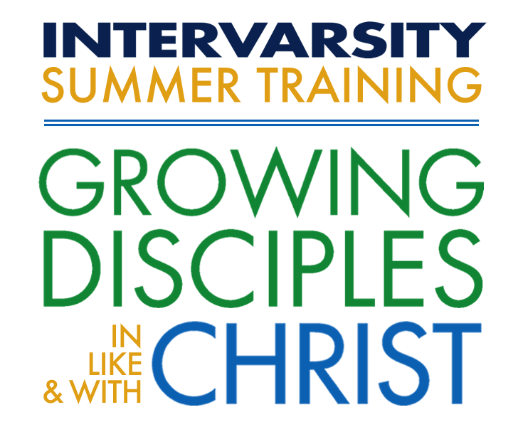

Table of Contents
Ministry Partner & Student Crew 1
Table of Contents 2
Track Overview 3
Track Description 3
Learning Outcomes 3
Schedule (Subject to change) 4
Friday 8:00 AM 5
Retreat of Silence Guide 6
Sunday 8:45 AM 9

Track Overview

Track Description
Can you really serve God by cleaning bathrooms, hauling firewood, and slicing mountains of vegetables? Yes! Join the Cedar Campus crew for a week-long lesson in practical servanthood. You will have the opportunity to serve God, your chapter, other students and Cedar Campus. Because of your work schedule you will not always be free when students in other tracks have free time. However, all crew track participants will be able to attend evening worship, Bible teaching, and chapter prayer times.

Learning Outcomes
By the end of this track participants will be able to...
- See simple acts of service as opportunities to be put on display for God’s glory. (Session 3 manuscript)
- Grow in 2-3 areas of service as they work in a group setting under the direction of supervision.
- Have modeled a way to lead a short Bible study and prayer time with co-workers in their workplace or internship over the summer. (Session 4)

Schedule (Subject to change)
Thursday
afternoon/Early Evening: Arrival
7:00-7:30 PM: Brief Orientation and Welcome Meeting
7:45-9:15 PM: Attend CFW Large Group meeting
Friday
8:00-8:45 AM: Breakfast/Bible study and information meeting
9:15-12:30 PM: Camp turnover
12:30-1:15 PM: Lunch
1:15-5:00 PM: Finish Camp Turnover, Special Projects, Kitchen Help as assigned
6:30-7:00 PM: Dinner
7:00- ??? PM: Free Time
Saturday
8:00-8:45 AM: Breakfast
9:00-12:30 AM: Kitchen help
12:30-1:15 PM: Lunch
1:15-6:00 PM: Kitchen Help, Registration, Special Projects
6:30-7:00 PM: Dinner
7:00-8:00 PM: Free Time
8:00-9:15 PM: Attend CFW Large Group
Sunday
8:45-9:15: Final Meeting/Debrief
9:15-10 AM: Breakfast/Pack Sack Lunch
10:30-12:00 PM: Attend CFW Large Group
12:00 PM: Eat lunch/Depart

Friday 8:00 AM
Psalm 122
- What things did you notice in this Psalm?
- What do you think this experience of going to the house of the Lord in Jerusalem was like for these traveling worshipers?
- In vs 3-5 How is Jerusalem described?
- What things does the psalmist pray will be given to the city (vs 6-9)

Application:
- As we think about the students getting ready to travel up to meet God next week, what are some ways we can pray in preparation for their time with God?

A song of ascents. Of David.
¹ I rejoiced with those who said to me,
“Let us go to the house of the Lord.”
² Our feet are standing
in your gates, Jerusalem.
³ Jerusalem is built like a city
that is closely compacted together.
⁴ That is where the tribes go up—
the tribes of the Lord—
to praise the name of the Lord
according to the statute given to Israel.
⁵ There stand the thrones for judgment,
the thrones of the house of David.
⁶ Pray for the peace of Jerusalem:
“May those who love you be secure.
⁷ May there be peace within your walls
and security within your citadels.”
⁸ For the sake of my family and friends,
I will say, “Peace be within you.”
⁹ For the sake of the house of the Lord our God,
I will seek your prosperity.

Retreat of Silence Guide
What is a Retreat of Silence?
- Retreat noun: a period of seclusion for the purposes of prayer and meditation.
- Silence noun: complete absence of sound

How to maximize your time
- Make sure you have: A Bible, a notebook and pen. Bring something to sit on or wrap yourself in if it’s cold out.
- Look for: A good place to sit away from people, away from noise. Look for somewhere in the sun, or near the water, or down your favorite trail. Don’t spent too much time hiking, but find a special quiet place to be still before God.
- Rest: It is okay to take a nap, and may be a good choice. If you do set an alarm so that you don’t sleep the entire time
- Music: Although this is a retreat of silence, you may choose to listen to some worship music as a way of connecting with God. However, let me encourage you to spend some of your time completely unplugged and listening for God’s still quite voice.

Let’s Begin:
- You have a lunch and free time, think of this as a lunch date with God.
- Enjoy the food He created -- chew, taste and enjoy with the body He created – look around at the sights He created
- Think through your year. There is no hurry. Think through all the things you have experienced this past year. Some possible areas to reflect on:
  - What happened with classes?
  - What happened with my family?
  - What did I experience in InterVarsity?
  - What happened with roommates?
  - In relationships?
  - In what ways have I served God?
    - What risks did I take or avoid?
    - Where did I see God at work?
  - Complete the phrase: This year I experienced ________________.)

In these times, exciting/dull, in victory/failure, joy/pain God was near and with you!

Read some of the following Psalms and meditate on them and write some reflections
- Psalms are prayers and songs. For much of the history of the church they were the primary source for worship. (dwell on these Psalms and suck out of them the truth and light they give about God and ourselves. Read extra slow and notice a phrase or two that strikes you; turn that phrase into a personal prayer)
- Psalm 6: David yearning to be in God’s presence and to be satisfied with only Him.
- Psalm: How meditating on God’s words transform us
.
- Psalm 107: Gives thanks for God, noting the various ways He meets and cares for the overwhelmed.
- Psalm 51: David’s prayer of confession expressing great sorrow at his own deep failure; but also, expressing great hope in God’s restoration and future use of David.

Question for Reflection and sometime of Prayer
- How often do you pray honestly?
- God already sees everything, there is nothing we can hide. God loves you and seeks to transform you into His image – He seeks to make you holy, loving, wise, and beautiful. It is safe to be honest before God and to reveal to Him things we may even hide from ourselves. Spend time expressing simple honest prayers to God. It may help to speak out loud.
  - Adoration prayers: Spend time praising God for simply who He is. CREATER, WISE, JUST, LOVE, PATIENT, FAITHFUL, etc.
  - Confession prayers: Spend time honestly coming clean about ways you have been unfaithful to God or hurt others.
  - Thanksgiving prayers: Sincerely thank God for specific ways he has cared for you
  - Supplication prayers: Earnestly pray for people and issues that God has put on your heart – know that He is powerful and hears your prayers.

Sunday 8:45 AM
- What were some of your favorite interactions with Students?
- What are some of your highlights/lowlights?
- What is your next step? How might God be inviting you to grow your partnership with InterVarsity?

